4/5/2024

Elizabeth Muir

The Wealth of Nations

Data Visualisation

Contents

Introduction 2

Scenario 2

Policies and Procedures 3

GDPR – General Data Protection Regulation 2018 3

Excel 5

Introduction 5

Security 6

Cleaning Data 7

Creating a table – Top 20 ranked countries per GDP 8

Table 2- Top 20 highest ranking Countries 15

Tableau 21

Introduction 21

Getting Started 21

Chart 1 – Top 20 Countries Life Expectancy 26

Chart 2 – Top 20 Highest Raking Countries per GDP 34

Chart 3 – Top 20 Countries Smartphone Users 42

Chart 4 – Top 20 Ranked Countries Life Expectancy 47

Wealth of Nations Dashboard 56

Link to dashboard 72

Reflections 73

References 74

# Introduction

This assignment showcases the skills that I have studied during the first two weeks of learning Excel Spreadsheets and Tableau. I will discover the policies and procedures that are necessary when working with data, providing emphasis on why adherence to the guidelines is important, the awareness that is needed and why it is vital for data analysts. I will additionally demonstrate how to secure our work providing necessary safeguarding before delving in to manipulating data. I will provide a step-by-step process on how to create tables in Excel, followed by the creation of charts and a dashboard in Tableau that is tailored towards our client’s specification.

## Scenario

Data visualization has become an essential business capability to help transform information into insights that can drive meaningful business outcomes and improved experiences. Today, most organisations have accumulated a wealth of data from different corners of their businesses, they are then unable to see how this data can help them make better decisions, making actions, and results.

You have been asked to look at the data workbook and familiarise yourself with this data. You have also been asked to create a visual report that will show the data in the form of charts and maps using Tableau to the client requirements. You will also need to consider data protection and computer misuse policies.

# Policies and Procedures

In a data analyst role, daily tasks involve the handling and analysing of data. There are policies in place that are vital to know within organisations to ensure that analysts follow legal standards, maintains the quality of data, and follows ethical guidelines. These policies not only protect the organisation but also to establish how trustworthy the analyst is.

Policies that are key when working with data include:

**Lawfulness, fairness, and transparency**

When it comes to personal data, we must ensure that when it is processed it has to be done fairly, by the law and with full transparency of how it is being used.

**Purpose Limitation**

The collection of data should only be undertaken for the right purposes and that it is specific to the company.

**Data minimization**

This policy is to ensure that companies only get the relevant information that they need.

**Accuracy**

This is to ensure that all data that is collected is fully accurate and fully updated.

**Storage Limitation**

This is to ensure that data is not stored for longer than it should be.

**Integrity and Confidentiality**

This policy is about the security of the data. All personal data must be secure from attacks where data can be leaked. It also ensures data is processed in a lawful way and protected from accidental loss, destruction, and damage.

**Accountability**

This for those who have control over the data- known as data controllers, ensuring the compliance of laws such as GDPR and ensuring that policies and procedures are in place.

## GDPR – General Data Protection Regulation 2018

The General Data Protection Regulation is a law on how companies must handle the personal information of individuals. This was implemented in the European Union (EU) on 25th May 2018. GDPR applies to organisations not only to EU and the European Economic Area (EEA) but those who provide services and goods to the residents.

What does GDPR do:

1. **Protects the personal data**: Companies must keep certain personal data safe and secure, this can be your name, address, and email etc.
2. **Gives individuals control**: Individuals can have the say to what happens to their details. Every company you interact with must ask for permission before they can use your details, they also must inform you on how they will use it also.
3. **Access to your data**: At any time, you are allowed to access your data that companies have on you. This can also include a request your data at any time.
4. **Keeping companies responsible**: Rules must be followed by companies otherwise they will face heavy penalties.

Having this law in place, protects you as an individual and ensures compliance within companies making sure they handle your data with responsibility and security.

# Excel

## Introduction

For this assignment I will be working with a file called ‘The Wealth of Nations’. This file has three different sheets of data to work with, GDP, Life Expectancy and Smartphones. This data will show us the wealthiest countries, the life expectancy of those countries and how many smartphone users each country has. I will be working through some tasks showing you authentication, filtering, sorting, and creating of tables.

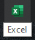

Firstly, we want to go to where our Excel is stored on our PC and open it.

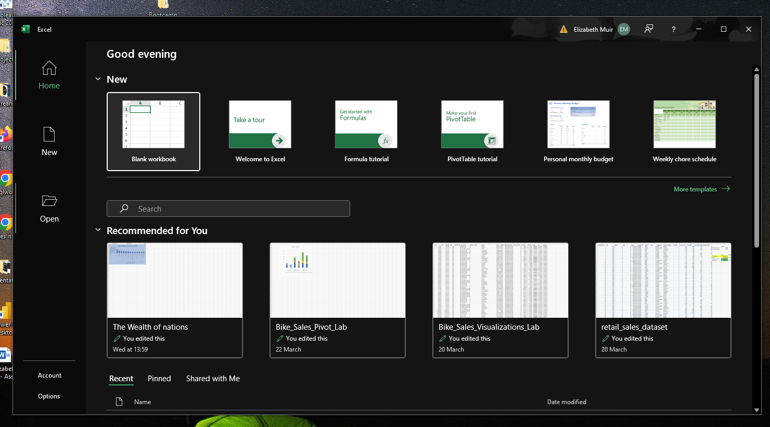



Once opened we see a welcome screen, this is where we will find our data file that we want to use and open it. Select open which is on the left-hand side.

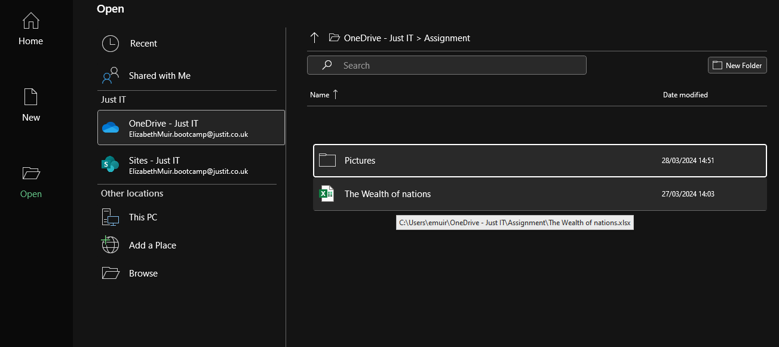

Once you have selected open this will allow you to search for the file on your system ready to use. This could be either on your OneDrive or on your PC itself. Once you have found it select it and press open. Mine is here in my OneDrive so all I must do now is select this and open.

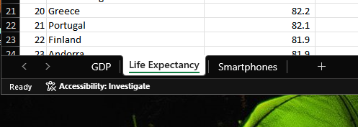

This is my spreadsheet open, and you can see at the bottom are the three different sheets that we can work with.

## Security

Before we get started with working with our data in Excel, we need to encrypt our file so that we can protect the data from anyone who is not authorised. This next section will take you through that.

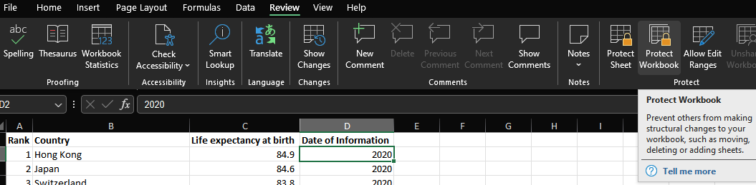

In our screen come up to our ribbon and select review. This will then give us options for checking our work and protecting it. In this case we are going to come over to the right and under protect going to select protect workbook. This will prevent anyone making any type of change to the spreadsheet such as deleting or adding fields or simply moving the sheets.

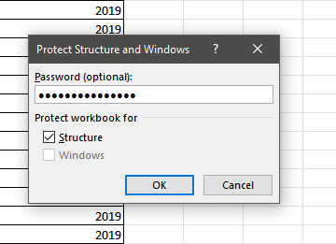

Once you have selected protect workbook this box will appear where it will ask you to enter a password to secure the spreadsheet with. Input a secure password and select OK.

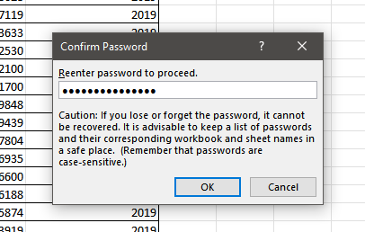

You will then be prompted to enter the password again to make sure that there is no problems or misspellings before securing the spreadsheet. Once you have inputted your password again select OK to secure. Just like that you have successfully secured your spreadsheet to ensure that no unauthorised individuals can access your spreadsheet.

## Cleaning Data

This next part we need to clean up our data on our spreadsheet. What I mean by clean-up is checking the data for any issues such as missing currency symbols or filling in a missing data also known as NULL data, pretty much anything that could cause an issue when performing tasks such creating charts or searching for information. For this spreadsheet I will be showing you how to apply filters and inputting a currency for the GDP.

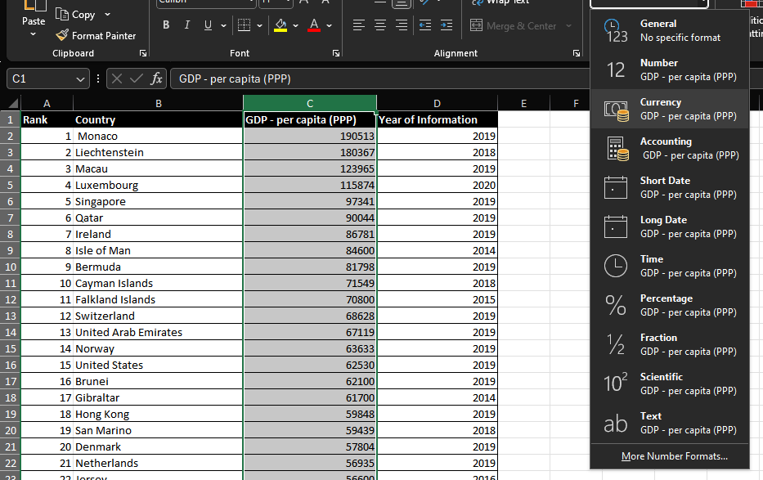

Firstly, you want to make sure that you are on the Home tab of the ribbon. Next select the column that has the data you want to make into currency. So, for my spreadsheet here I have selected column C with the title GDP – Per Capita (PPP), as this data is the amount made per country, when it comes to creating any charts or searches, I want this to display as a currency and not an actual number as it may be confusing when presenting to others.

Once the data you want changing is selected go to the number tab and select where it says general. This will open a dropdown menu with different options of how you want the number to be displayed. For my spreadsheet here I want to make mine display as currency so I will select that.

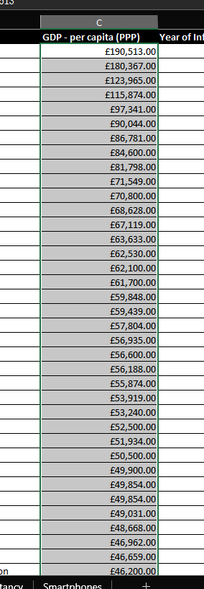

This is how my numbers display now once I have selected currency. This will make reporting and making charts look understandable to others when presented.

## Creating a table – Top 20 ranked countries per GDP

In these next steps I will be showing you how to make your data be presented in a table and to add a filter so you can display certain information that you would like to present to others. For my spreadsheet I will be filtering my information to display top 20 countries.

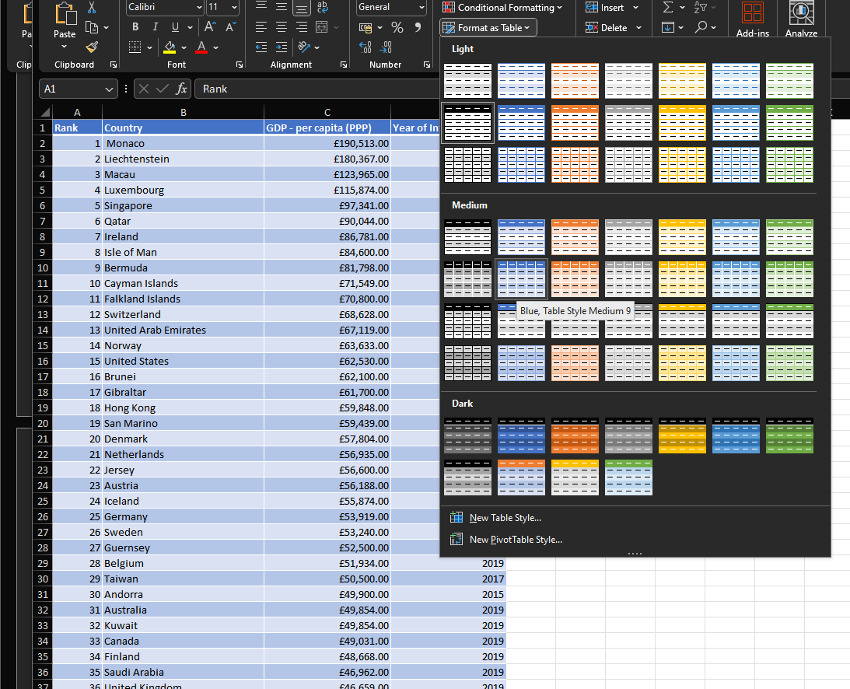

Firstly, you want to select all the data in your sheet, you want to click on the first cell and drag over the data. Under the home tab and under styles, select the format as a table button. This will bring up a dropdown menu with several different pre-made designs that you can use, you can also do your own colour scheme if you like by selecting New Table Style. For my spreadsheet you can see I have selected blue medium style, and this is what the data will look like using that design.

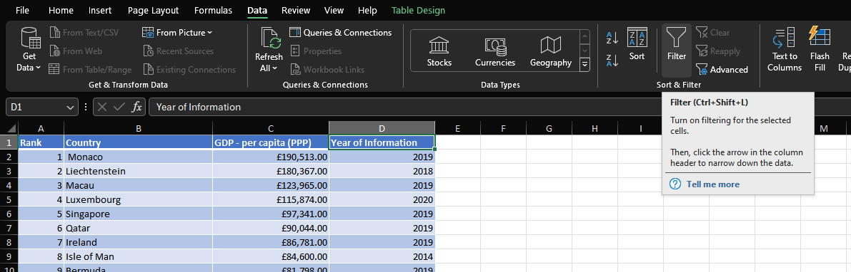

Now once we have decided what colour scheme, we want for our table we are going to add a filter to it so that we can make charts displaying certain data and not the whole lot. We want to select the cells that are the titles of our columns and head over to the data tab on our ribbon. From there under sort & filter select the button called filter.

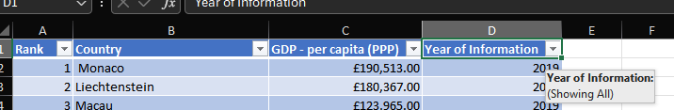

Once you have pressed the filter button you will see that the top row that has our headers now have an arrow box. This is the filter button ready to select what type of data that we want to display ready for reporting. The first thing I want to do is head to the cell called Year of Information and press the down arrow button.

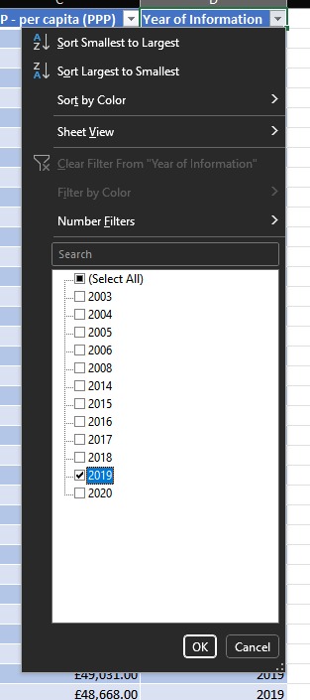

Once that is pressed this drop-down box appears showing all the years that are available within our data. There are other options such as sorting the information from smallest to largest and largest to smallest. You can also sort by colour and can put a number filter on. Number filters allow you to either check the average of certain data, if something is smaller or larger than another data amount or is equal to. You can also customise your own filter too depending on your specification. For my sheet here I only want to work with the year 2019 so I have deactivated the other years and left 2019 selected. Now press OK.

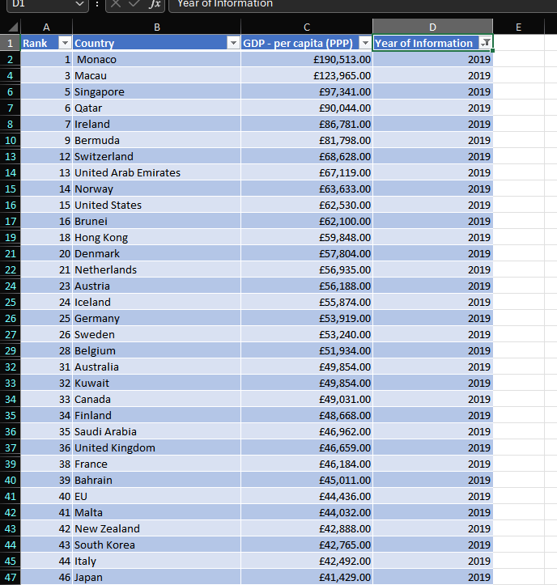

Now we can see the data has changed to only show Countries with the Year of Information as 2019.

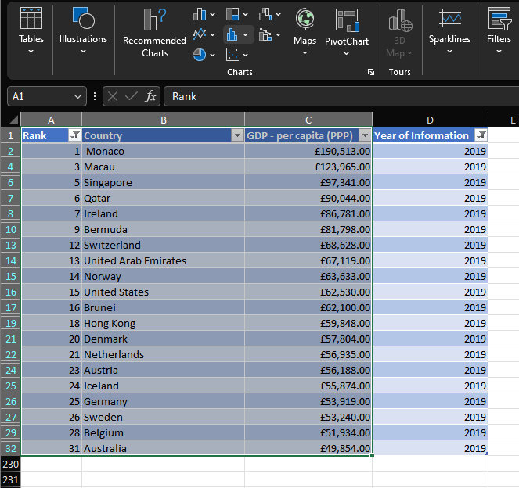

Now we are going to create a chart using the data we have now sorted using the filters to display 2019 and the top 20 Countries. I only want to display the Rank, Country, and GDP columns so I will highlight all the information in these columns ready to create a chart.

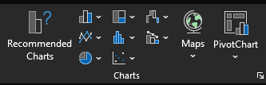

We then head to the insert tab on our ribbon and under charts we want to select what type of chart that we want to use to display our data.

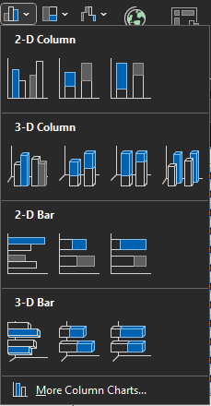



I have chosen to use a bar chart, so I select bar chart and it comes up with this dropdown box with different types of bar charts that we would like to use. Anything from 2-D to 3-D charts. I am just sticking to a normal 2-D bar chart with simple columns.

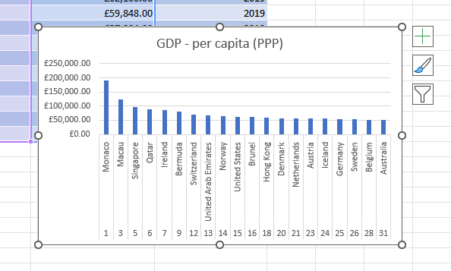

Once selected what type of chart that you would like to use your data will present as such. We have a title, the GDP on the left side (X-Axis), and Countries and their Rank on the bottom (Y-Axis). As we can see the chart is quite simple but not very understandable if someone was to see it, we need to add more elements to it. Adding elements to the chart will ensure when it is presented, whoever is reading it will understand what type of information you have and what the chart is representing.

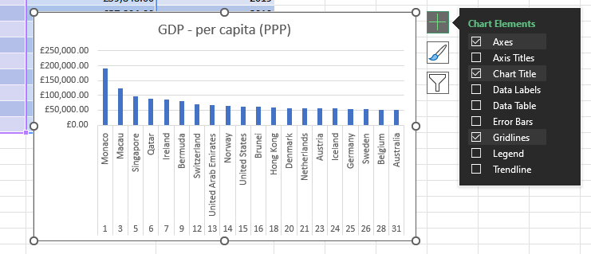

On the right side of the chart, you can see a plus sign. If you click here, it will open a dropdown menu with different chart elements that you can add or take off depending on your criteria. So far, the chart is ok, but I would like to add some labels to explain what data I am using on the chart, so I will be adding Axis Titles for the X-Axis and Y-Axis.

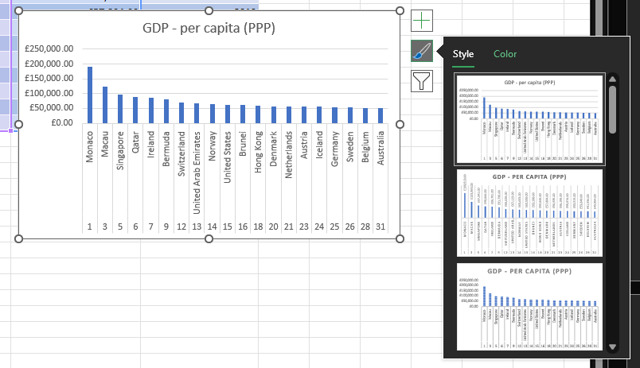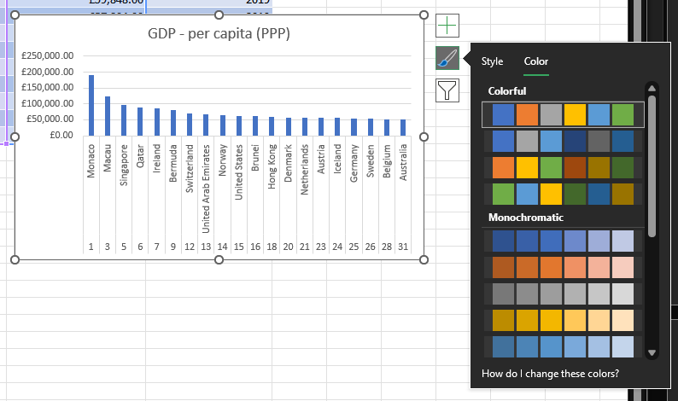

The next box down with the paintbrush is the styling of the chart. Clicking here you will see the dropdown menu displays many different premade stylings that you can choose from. If you select the colour tab you can choose from many different colour schemes to style your chart with.

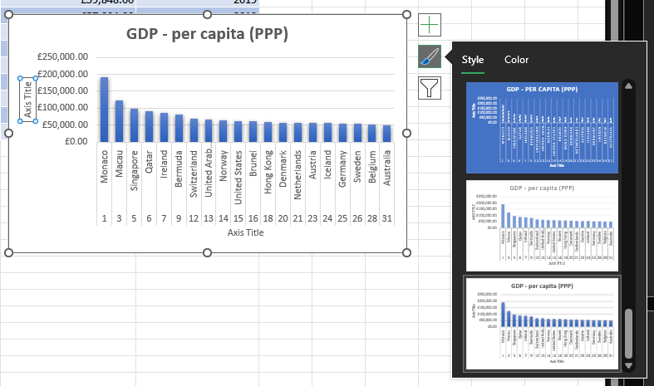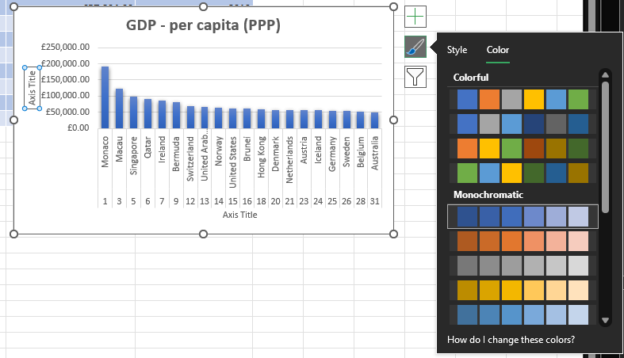

For my chart I have selected the last style making the bars have a bit of a gradient. I have then gone over to the colour header and selected a dark blue to light blue monochromatic colour to make the bars look a bit more solid and you can see in these images on how it looks.

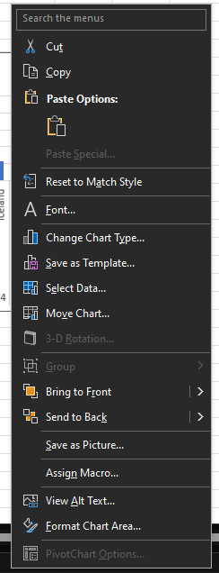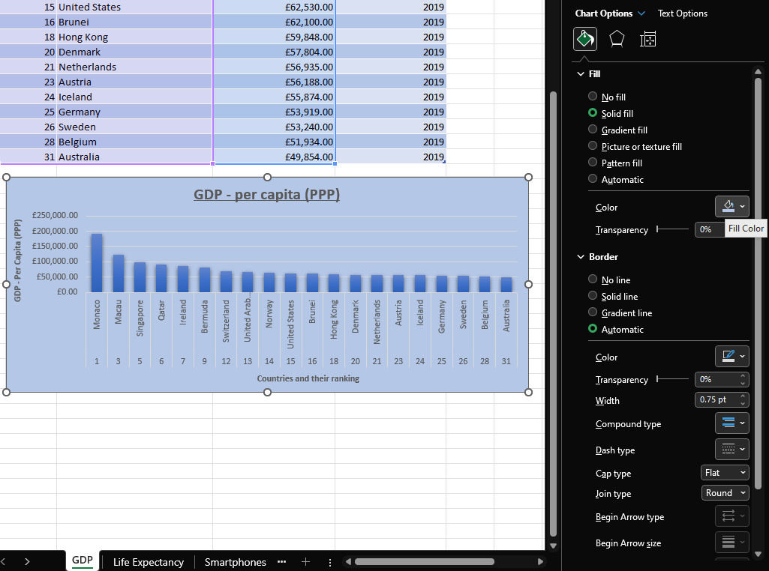



I want to go a bit further and put a background onto my chart to make it stand out a bit more. Firstly, I will right click my chart and select Format Chart Area. It will then open this side menu with many different options of styling the chart. Under fill I have many options to style the background from filling it with solid colour to patterns and a gradient. I have selected solid colour because I thought it would be easier on the eye. I have selected a light blue colour, so it doesn’t clash with the bars or the font of the chart.

|  |  |  |
| --- | --- | --- |
|  |  |  |

On my chart I also made some changes to the title and the axis’. The title better reflects what the chart is displaying to the reader, the axis’ displays the data that we have used to create this table and that is displayed in the chart. Without these the reader wouldn’t really understand what the chart is displaying without someone translating. The whole part of these features is to minimise that.

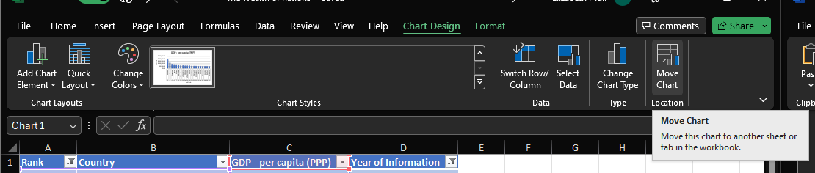

Now to better display our chart we want to move it to a new sheet so that we can display it without information all around it and so that we can work with the sheet further to create new charts for reporting without it affecting what we have created on this chart. Under the chart design tab on our ribbon, we want to select Move Chart which is the last option.

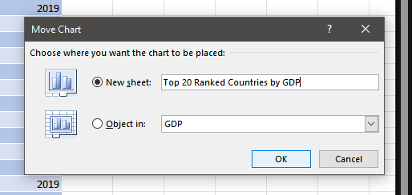

This prompt will appear asking where we would like to put our chart, either on a new sheet or on a sheet that is already existing within your file. I want to put my chart on a complete blank sheet, so as you can see, I have selected new sheet and named it Top 20 Ranked Countries by GDP. Then press OK.

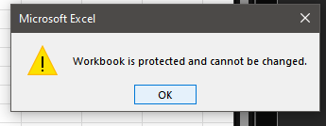

As you can see, I had an error whilst trying to move my sheet. Here you can see our encryption is working by telling us that it is protected and that we cannot make any changes to it. For me to make any changes I must go back and take the password off for now. I will then put the password back on once I have finished my work ready to send to whoever may need it after, this is to ensure that my work is protected and free from any changes being made to it by unauthorised individuals.

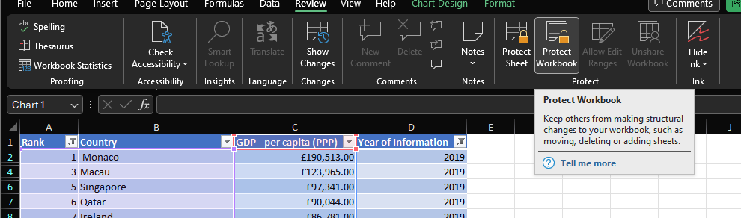

I go back to the review tab and select protect workbook. Once clicked it will ask me to enter my password to deactivate the protection for now. Once this is done, I can go back and move my chart on to the new sheet.

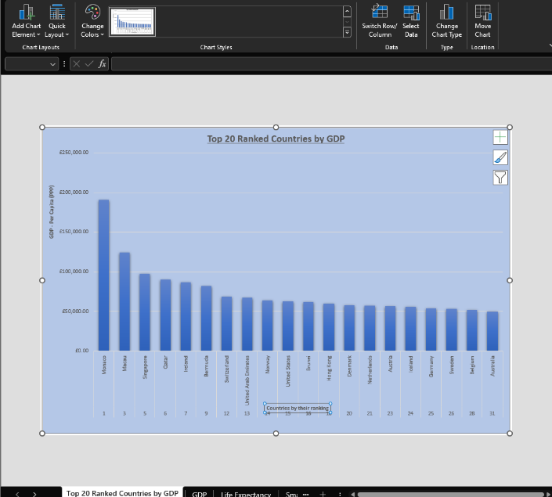

Again, I must go back to chart design and select Move Chart. I select new sheet and input the title Top 20 Ranked Countries by GDP as my title and hit OK. Once OK is selected the chart will then load into a new sheet as shown above. As you can see the chart looks more appealing being on a separate sheet without any interference from data or other charts you may have. You can keep formatting it if you need to.

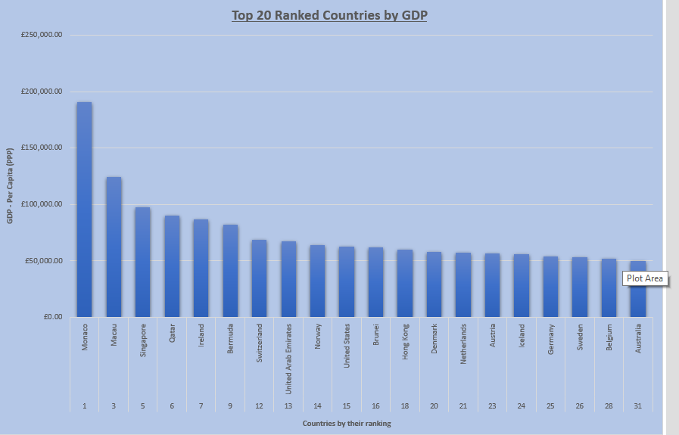

This is my final look of the chart that I have created. I am displaying the top 20 Countries by rank and their GDP for the year of 2019.

## Table 2- Top 20 highest ranking Countries

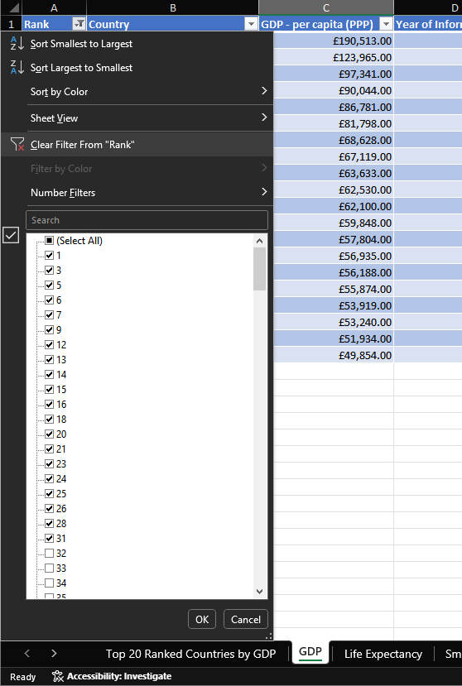



I am now going to create another table displaying the top twenty highest ranking countries. I first must go back to the GDP sheet of my Excel file. Then click the down arrow on the Rank cell. Here on the drop-down menu, I will select Clear Filter from “Rank” option, this will clear any of the filters that I placed.

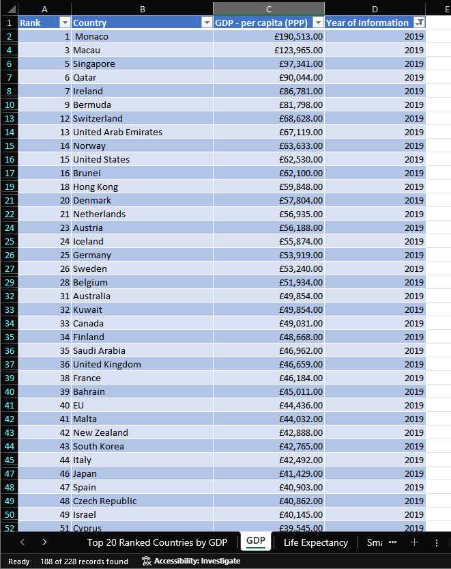

Once the filter has been cleared the data returns to the original state it was before the filter was placed.

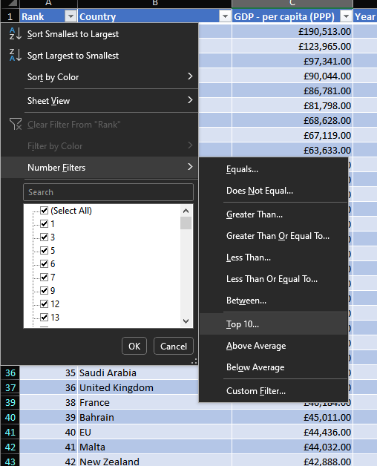

Now we are selecting the top 20 highest ranked countries, so this means we must put a filter on the column Rank. We select the down arrow again to open the filter dropdown menu and come down to Number Filters option. Once that is highlighted this will open another dropdown menu with different filters, we can place on the numbers such as average, greater than, equals and top 10. As we want the top 20, we are going to select top 10.

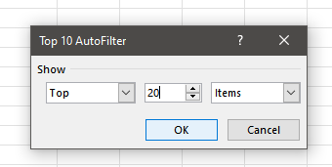

Clicking top 10 brings up this prompt where we can expand on the number of items we want in our filter. I am going to change 10 to 20. For any other times you can use smaller or larger numbers and if you want it from the bottom.

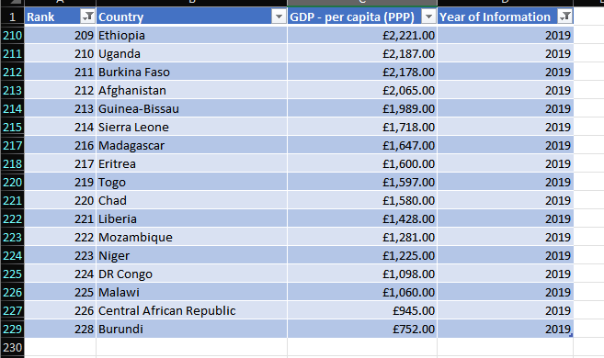

Once we have pressed OK you can now see that the table displays the highest-ranking countries.

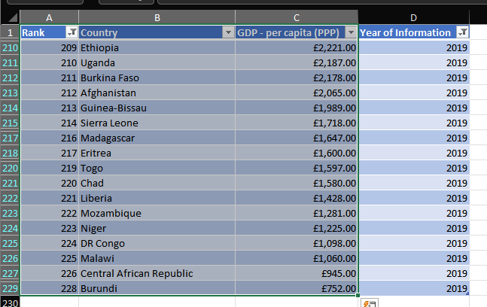

Again, we are going to use this data to create a chart. So, we are going to select the Rank, Country, and GDP columns again and highlight all the data underneath.

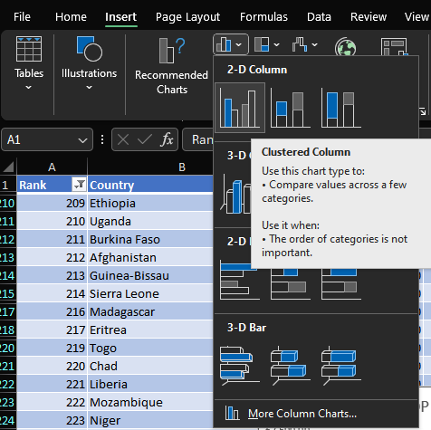

Then under the insert tab on the ribbon we are going to select bar chart again to display our data.

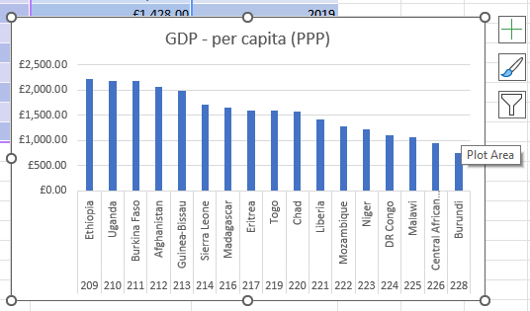

Again, our chart appears on our page with all our data present on a bar chart. We are going to present our chart on the same page as our data, so I need to position it so that we can read the data and the chart at the same time.

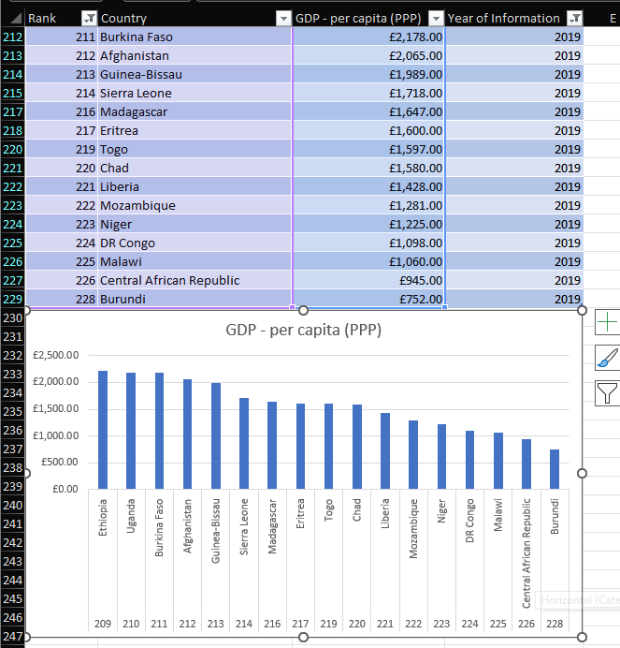

Here you can see that I have made the chart display underneath the data so that you can read the data and then lead onto the chart. Presenting it this way keeps it in one page easy to read and not all messy and over the place.

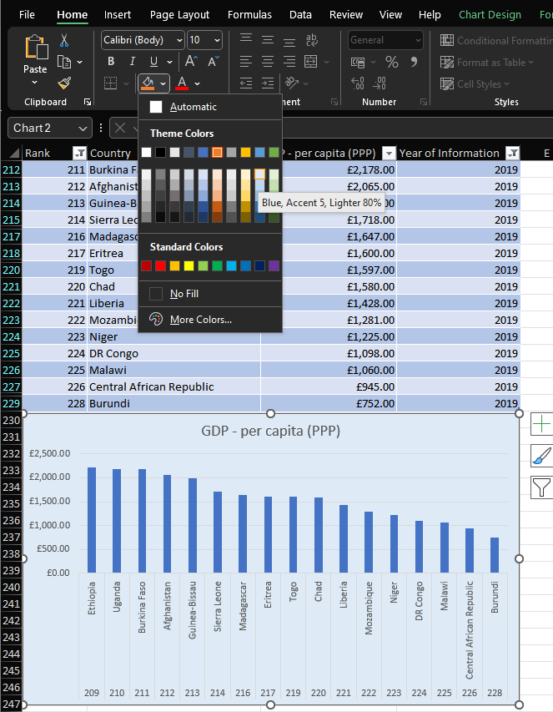

So, for formatting I will quickly show you another way that you can put a background colour on the chart. Come up onto your ribbon and under home and where our font and font sizes are we can see a box with a paint pot. This means we can change the background of the item we are working with. Again, you can see so many different colours and have the option to even expand on the colours. To keep it quite simple I have selected a light blue making sure that the chart is still readable.

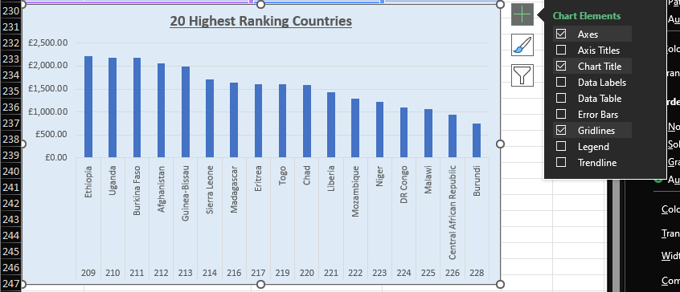

As you can see the chart doesn’t have any labels on the axis’ so I will come over to the right and select the plus sign to open the features list. I am going to select axis titles ready to label my chart.

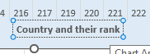 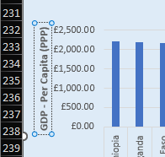

I am going to rename the axis’ so that the chart is easily readable to readers, so they know what the chart is displaying.

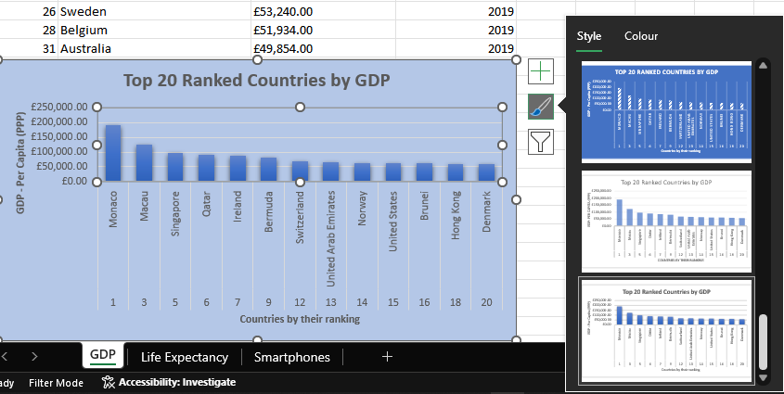

Now I have my axis’ done I am now styling my chart. I select the paintbrush icon and select the style that I want. For this chart I am using the same design that I used for my first chart.

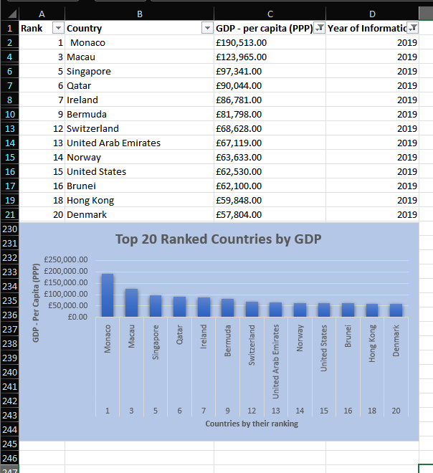

Now our chart is complete. We have all the necessary labels to explain what our chart is displaying and formatted in the way that it is easy on the eye.

# Tableau

## Introduction

For this section I will be taking the excel spreadsheet and adding it to Tableau to make different various charts in a visual way to create a dashboard for my client. The client has a couple of requests when it comes to the creation of this dashboard, one being that the charts show the top 20 highest ranking countries and secondly as they are colour blind the dashboard being presented in a way they can see well.

Before I created my charts, I did some research to see the best colours that are used for those who are colour blind so that I could take that into consideration when I am creating the charts. The research has shown that blues and oranges are friendly colours to use most of the time, if you must use certain colours, it also shows blue/red and blue/brown would also work. Luckily in Tableau they already have a colour palette with these colours included so you wouldn’t have to worry about choosing the wrong colours. But with research you can see some other colours can work along with blue.

## Getting Started

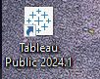

Getting started we are going to select Tableau on our system and open it up.

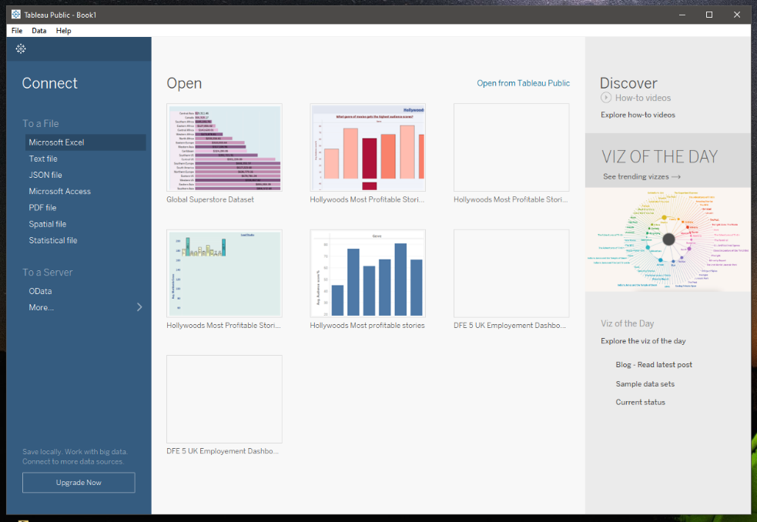



Once Tableau has opened it will display this home page. This is where you can load previous files that you have created, view Viz of the Day or load even load a new data file.

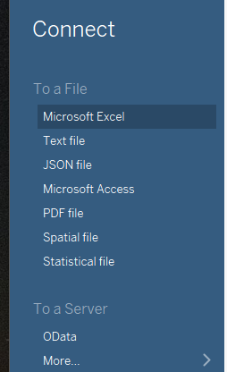

For this project we are going to load our Microsoft Excel file ‘Wealth of Nations’ into Tableau ready to create some visuals. So come over to the left-hand part of the home screen and select Microsoft Excel.

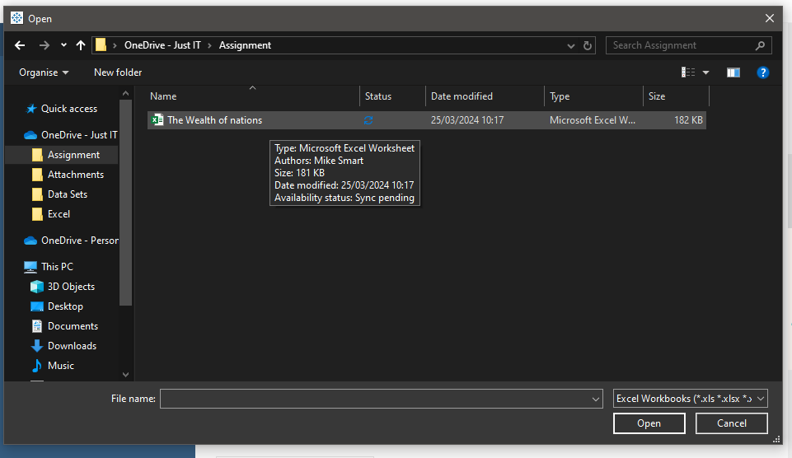

This will load this prompt box asking you to choose your file to load into Tableau. Head to the folder where you have it stored on your PC and press Open.

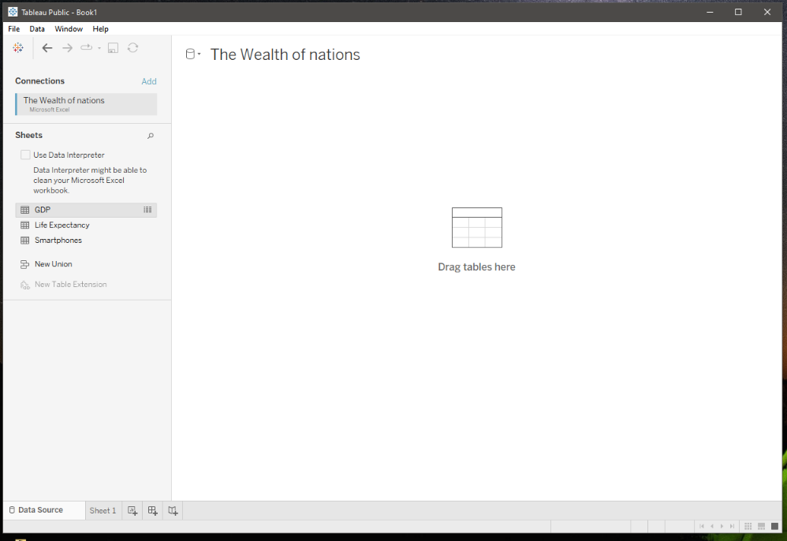

Once you have selected open you will have this page appear. We know our file has loaded correctly because our title of our file is at the top - ‘The Wealth of Nations’, we can also see at the left-hand side our sheets are displayed.

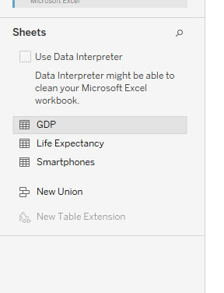

Now we have confirmed that the Excel file has loaded fine we need to start connecting our sheets together through relationships. We use relationships to combine data from a multiple number of sheets to use for analysis. We describe how the relationship relates together by common fields.

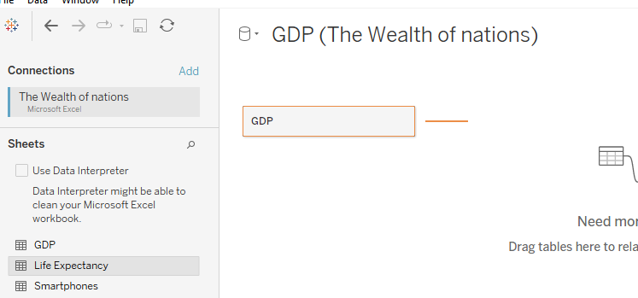

To start our relationships off we first must drag a table over. Here I have selected the sheet called GDP and it will appear here as shown.

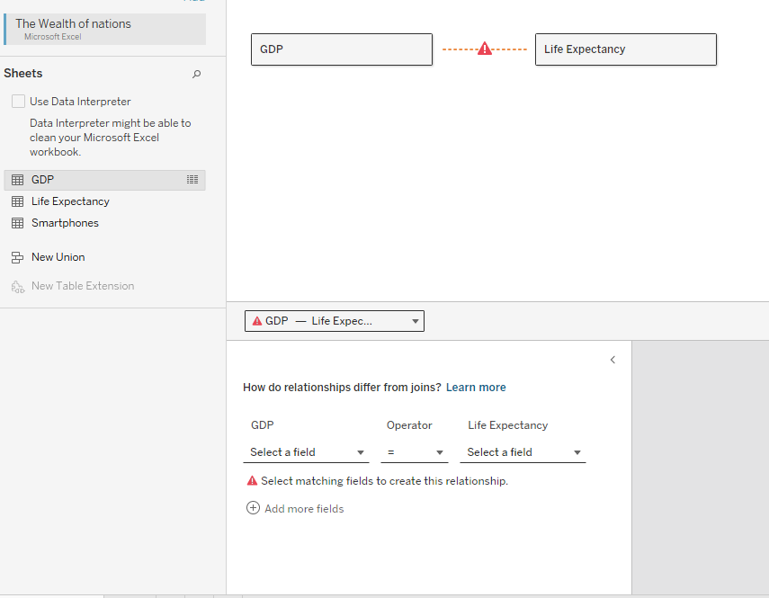

We now going to drag over the Life Expectancy sheet next to GDP as shown above. Once it has been dragged over a red dotted line with an alert sign appears. This tells us that we must define what makes these two sheets relate together.

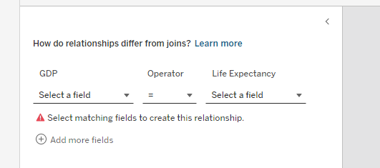

Looking at the bottom of the page, you will see GDP on one side and Life Expectancy on the other. We need to select what field on each of the sheets that relate together. Go to ‘Select a field’.

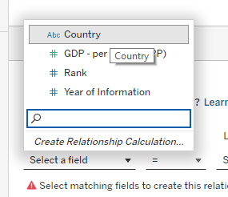 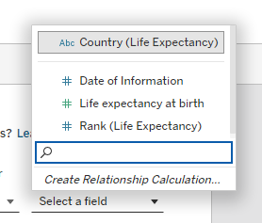

You will then have a dropdown box appear. This will display the fields that are on the sheet. Here we have Country, GDP, Rank and Year of Information. We want to select Country as this is the same field for each sheet that doesn’t change. We do the same for Life Expectancy also, press ‘Select a field’ and the dropdown box will appear, again select Country to confirm this relationship.

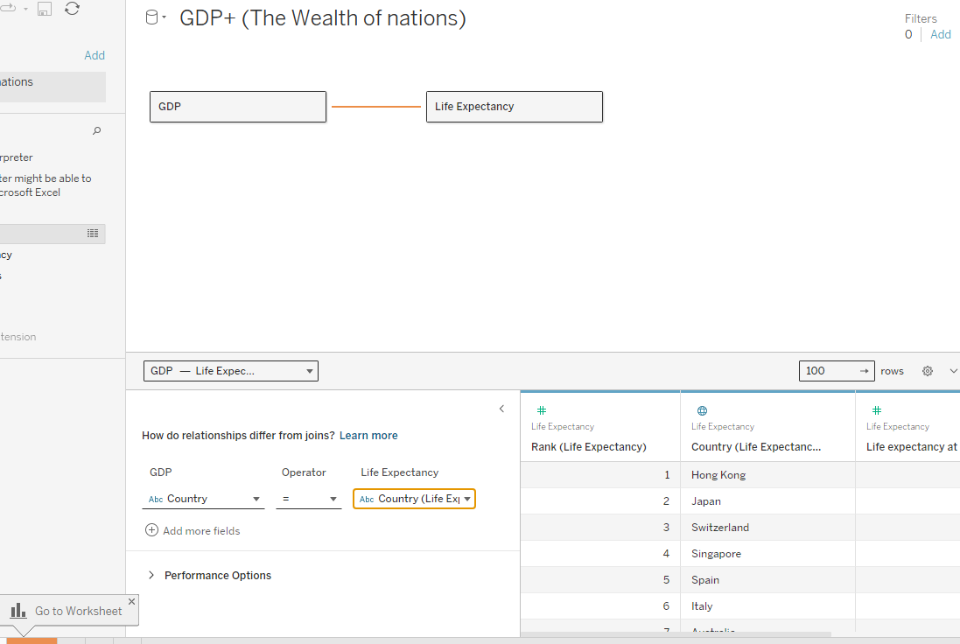

Once Country has been selected you will now see the line change to orange between GDP and Life Expectancy, this confirms that the relationship works and is ready to work with. Before doing so we have to add our last sheet Smartphones.

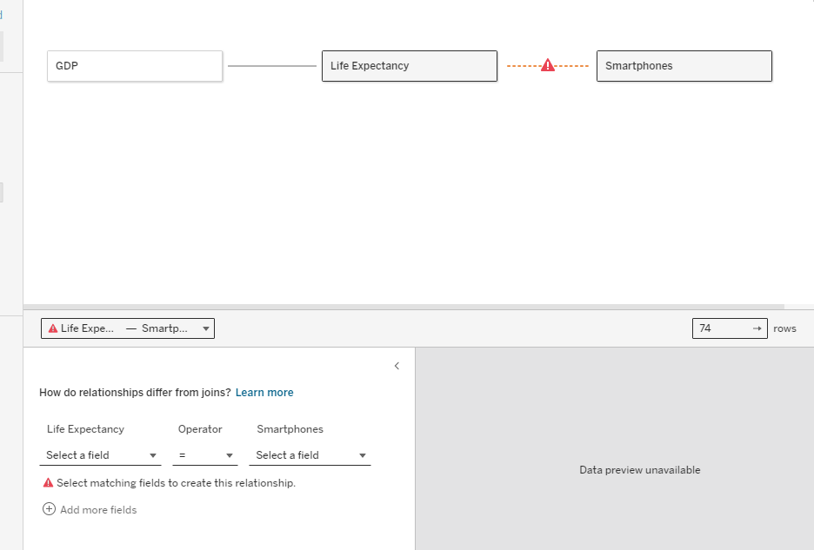

We select Smartphones and drag it over to where we have GDP and Life Expectancy is ready to connect. Once Smartphones has displayed, we have the red dotted line with an alert sign meaning we must finish connecting the relationship.

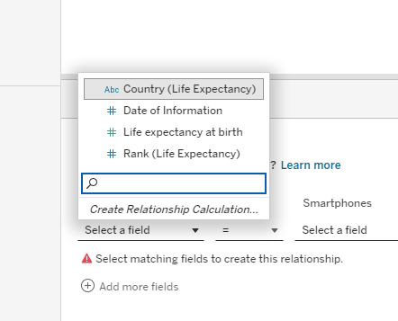

Pressing Select a field we load the dropdown again with all our fields on. Here select Country again as this is our connecting field to all our sheets and do the same with the Select a field box under Smartphones.

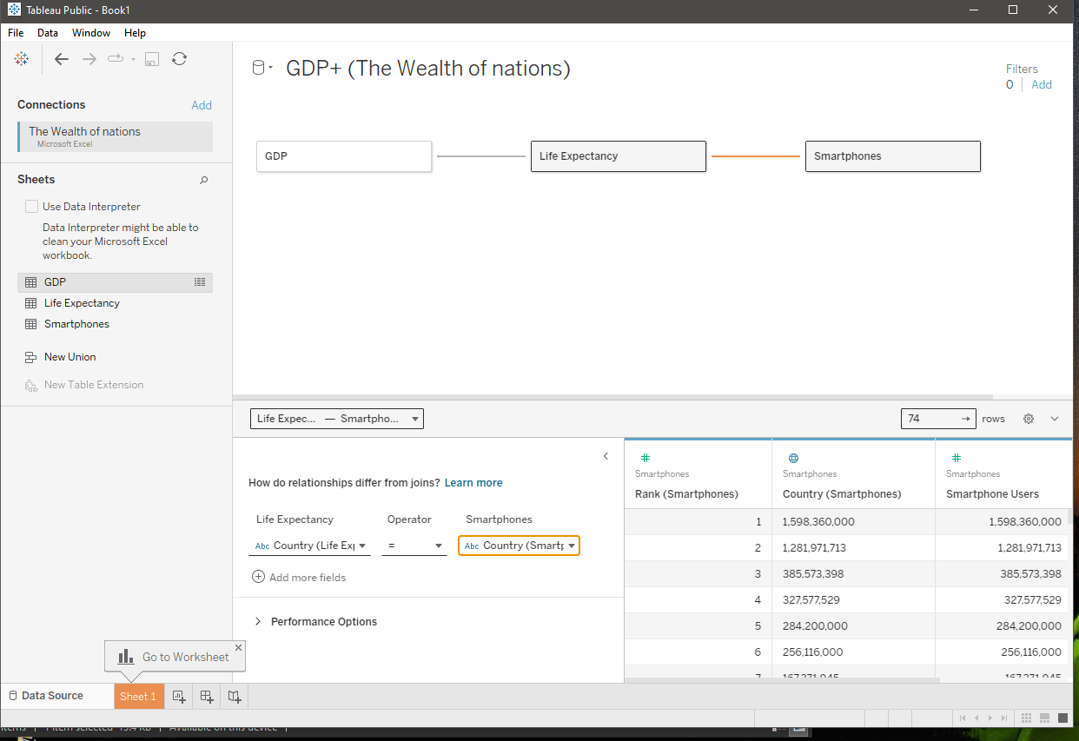

Now we have selected our Country fields for our relationship we can see the orange line confirming that the sheets are connected.

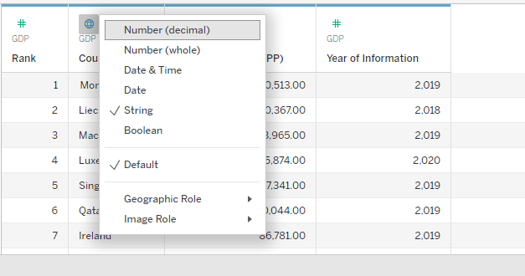 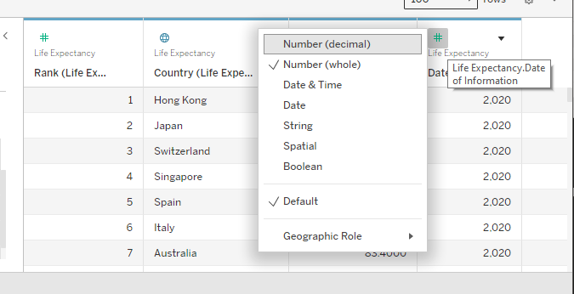 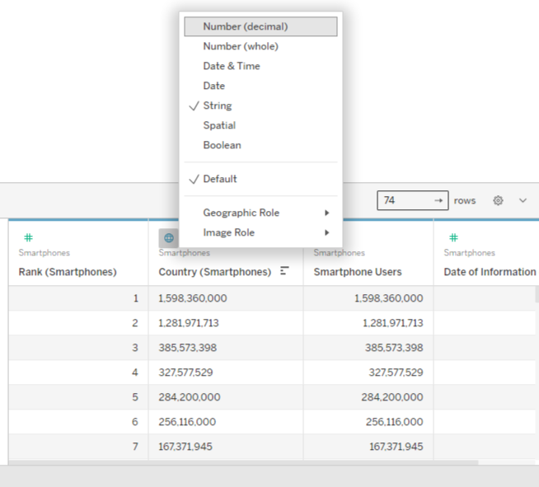

Now to the bottom right of our screen we can see each of our sheets and their fields. We want to go over and check that all data is present and has the correct data types so that we do not run into any issues when creating charts for our dashboard. Clicking on the icons opens a dropdown box showing you all the different data types that are available. We have a decimal number, whole number, date & time, date, string, and Boolean. We need to check the data types because sometimes in the process of transferring our files to another program some may mess up and don’t want to wait till when we are in the middle of creating charts have an issue of data not displaying right.

## Chart 1 – Top 20 Countries Life Expectancy

Now once our data types are correct and our relationships are connected, we are now ready to get creative and create some charts to display onto our dashboard.

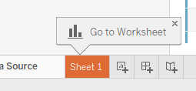

To start off with we go to the bottom left corner of our screen, and we see that a sheet has already been made so we click this to load our sheet up.

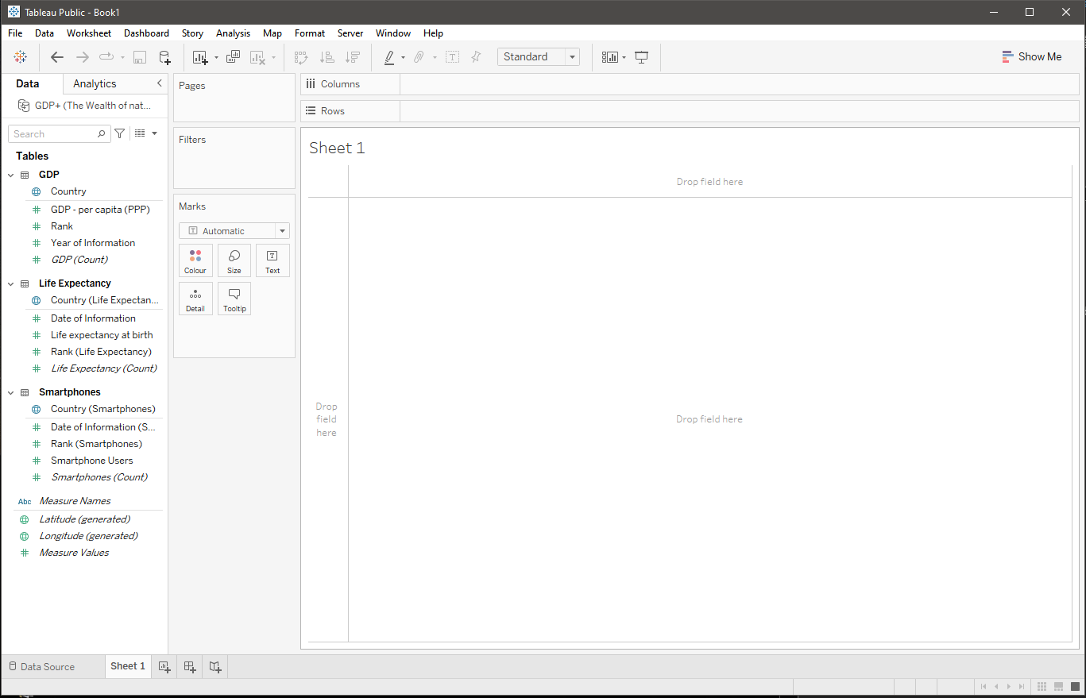

This loads our page up ready to make our charts for our dashboard. This is where we can make charts using the fields in our sheets from our connected file. We have many different options we can play with, and I will be taking you through most of them as we create our sheets for the dashboard.

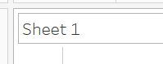

To start off we want to put a title to our sheet, this is to show everyone who reads the dashboard what the chart is displaying. Come to the top where it says Sheet 1 and double click.

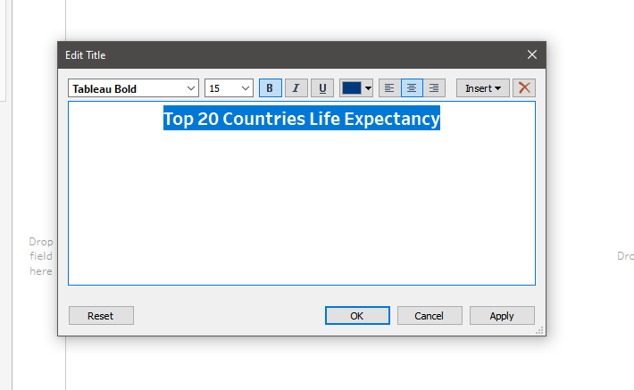

This will bring up a box where you will be able to change the text. There are also options to change the font, size, bold, italic, underline, colour, alignment and if you want to insert something into this box. I have put the title that I want and changed the colour to blue as per my research about colour blindness. I have kept the font the same but just made sure that it was bold and aligned to the middle. Once you have changed everything you want for your title press OK.

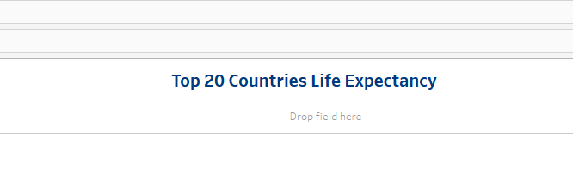

This will then display our title on the page. This is what it currently looks like as per my formatting.

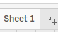 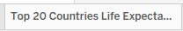

Before we go any further, we want to make sure that our sheet has a title also. Head down to the bottom left of your screen where it says sheet one, double click here and put in your sheet name and press enter. This makes it easier to define the sheet later when we create our dashboard. I have just renamed sheet one to the same as my title.

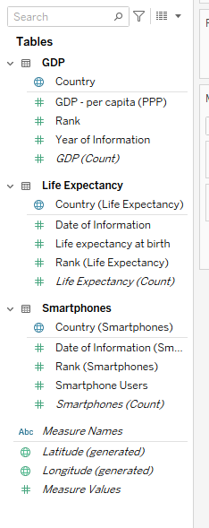

Time for the fun part we now want to select what fields that we need to start creating our chart. As my chart is the Top 20 Countries Life Expectancy, I firstly want to select Country. We come to the left-hand side of our page, and we can see each sheet with their field names, from here I want to go under Life Expectancy and select Country and Life Expectancy at Birth fields.

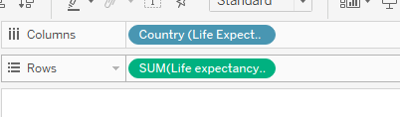

We select each field one at a time and drag them up to the top where columns and rows are displayed. For now, it doesn’t matter where they are because when it comes to formatting the chart to the way we want they will change position also. But this is what they look like now just to get our chart started.

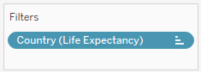

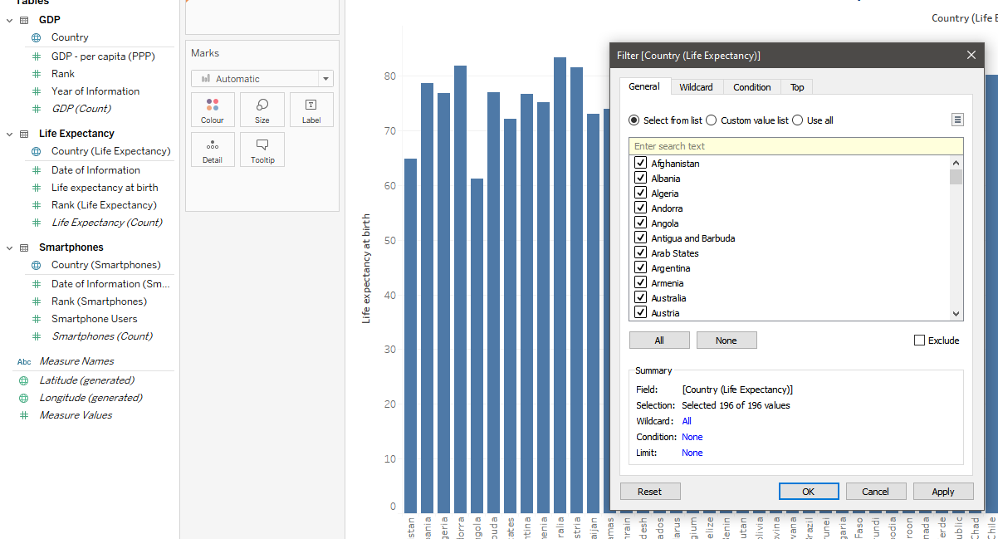

As this picture shows once we have our fields in the columns and rows place our chart will form. Before I move on to do anything else I want to make sure that the chart shows the top 20 Countries, to do this we have to create a filter. To create a filter, we must come over to the left of our page again and select Country and drag it to filters. Once this is placed a box appears with different options to select from to create any filters we want with this field.

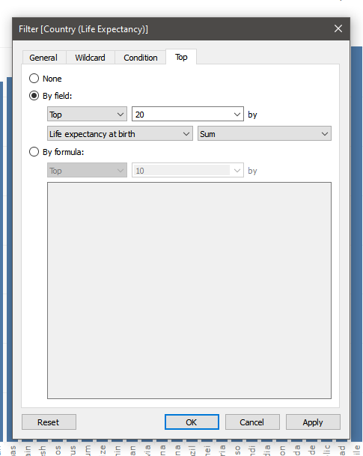

As we are wanting the top 20, we want to select the top tab. This is an easy way to select a top amount of data. You have two options one is by field, and the other is by formula, we are selecting by field and going to change the number ten to twenty. Once we have done that press OK.

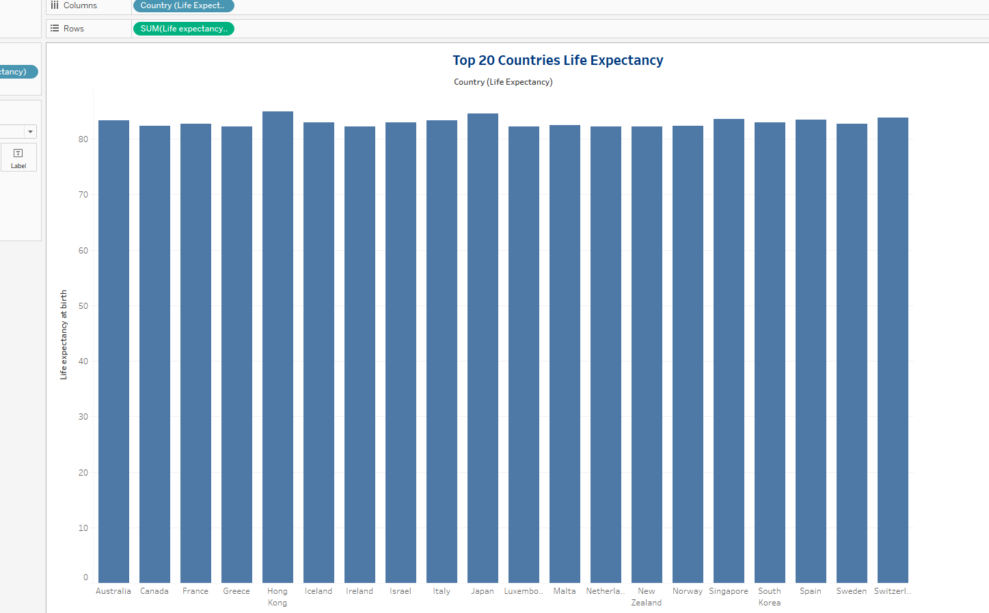

This chart now displays the top 20 countries life expectancy.

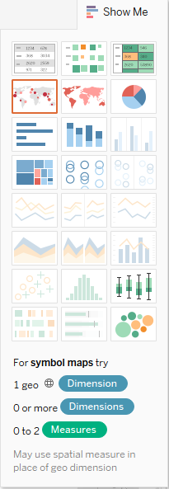



Our chart looks a bit boring, so we are now going to format it. If you go to the right top corner of our page, you will see a tab that says Show Me, click here to bring up a dropdown box with various charts. This tab shows you all the available charts that you can use to present the data that you have currently on your page. As we go on you will see that certain charts will appear depending on what fields are selected. For this chart I would like to use a map, there are two different variants of a map that you can use, one shows actual countries coloured in or you can have spots over the countries. I have selected the shaded version.

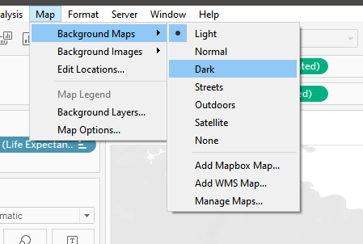

As we have chosen a map, we can head over to the map tab at the top of our page and choose what type of background we would like on our map. There are many versions we can select and below shows the way that they look. Left to right we have normal, dark, streets/outdoor and satellite.

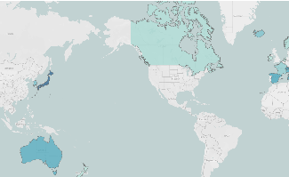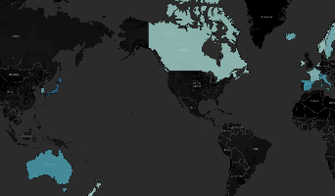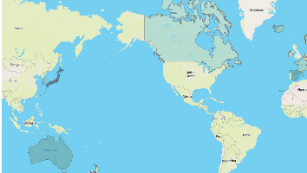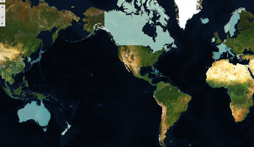

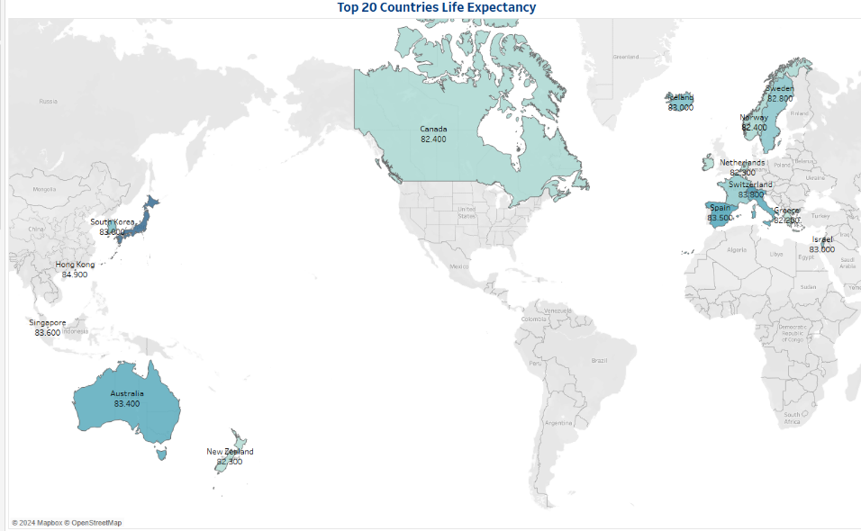

For my map I have selected the light version. This is because I have to work with colours that are friendly to readers who are colour blind, I wouldn’t want any of the other colours to clash or be messy to read.

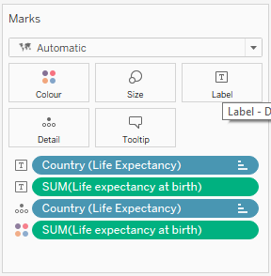

Before we head on, I want to label my map so that you can see the country names and the life expectancy age. We have to get the fields from the left of our page and drag them over to the label button under the Marks section. This will display the details on the map.

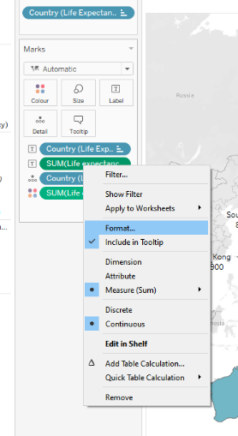 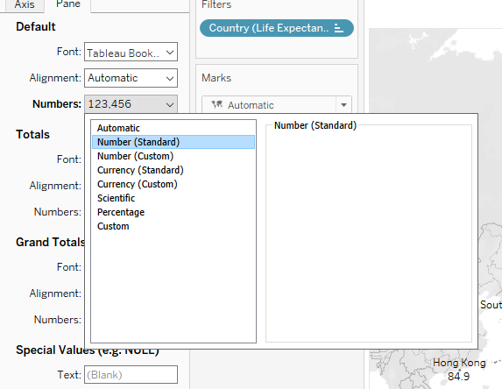

My numbers are looking a bit weird for ages as they are displaying 00 at the end and we don’t associate age in that way, so this is going to be formatted. We right click the life expectancy at birth label, which has a text box beside it to let you know that it is a label and select format. This will bring up a side pane on the left with different options to format from font, the alignment and how the numbers are going to be displayed. Under numbers this is where it will give us the option to change the presentation, in the dropdown menu you can see many options from a general number to currency to percentages. We want to select standard number as it is just a decimal number that we want.

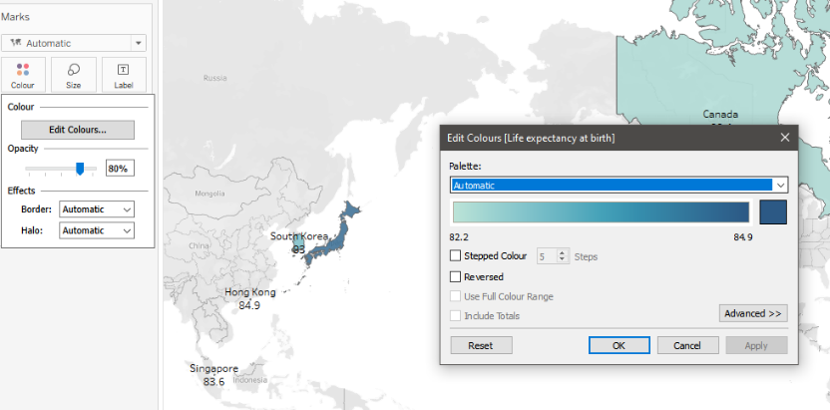

Next in our formatting we want to edit the colours that are on the map. We go over to the Marks section and select colour; this is where the edit colours box will appear.

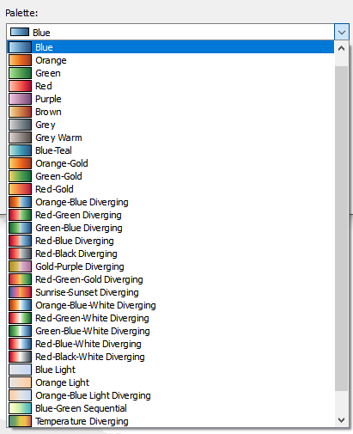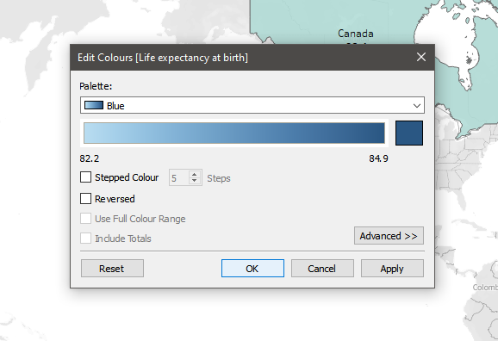

If you click palette, you have a huge amount of choice to pick to design you map with. They are all displayed as gradient as that is how the scale goes when presenting on a map. There is an option for stepped colour, this allows you to choose how many colour steps the map can take to lead from one shade of blue to the next. I am sticking with blue for my map as this is one of the best colours to use for readers who are colour blind. You also have the option to reverse the colours but for now we are going to leave that option unchecked. Once you have selected your colour you can press OK.

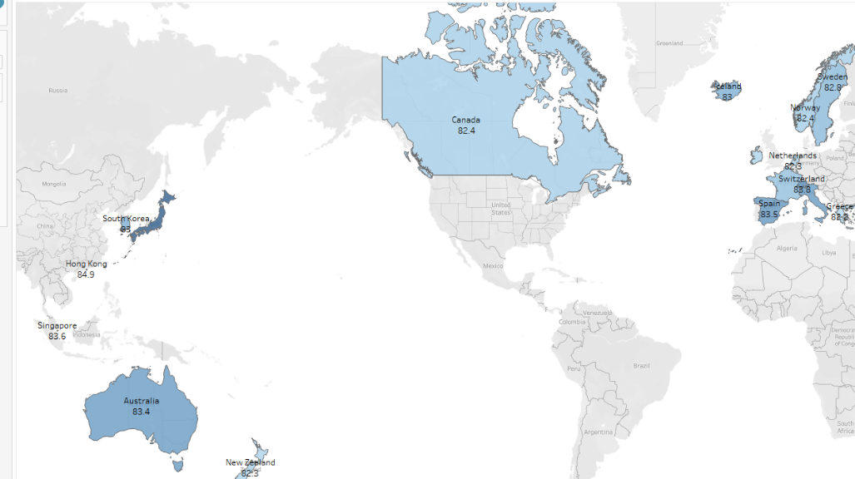

This is how the map looks with that colour choice that I have selected. Now we are going to format the labels.

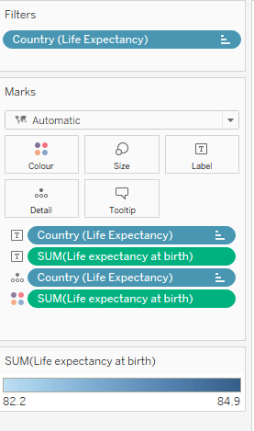 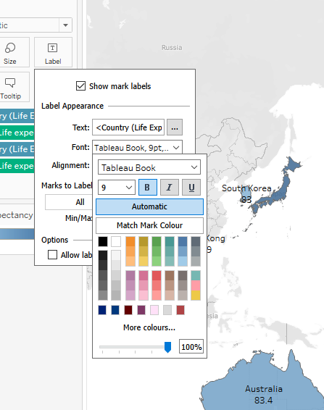

We come back to the Marks section. Select Label and the options box opens. Here we can format the font, alignment, and colour. For my labels I want them to be blue and bold so that our readers can see it well.

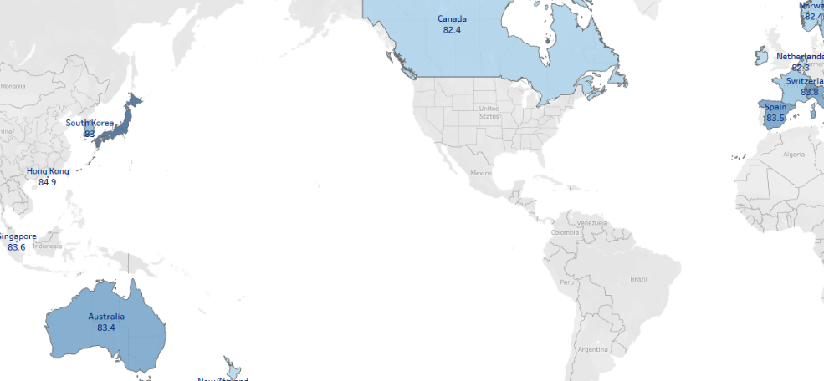

This is what our finished map looks like, simple but effective and simple to read. This map will be ready to display on our dashboard later.

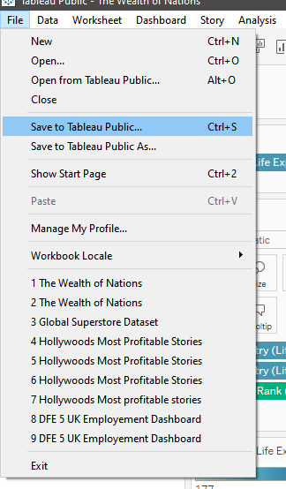 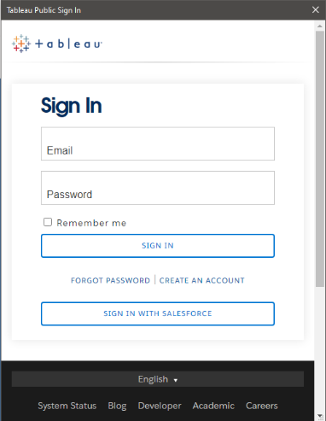

Now we are ready to start saving our work. Go to File and Save to Tableau Public. When first saving Tableau will load a sign in page. This will allow you to create an account or just sign in. Simply enter your details to start saving your work.

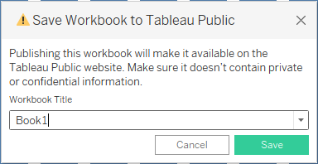 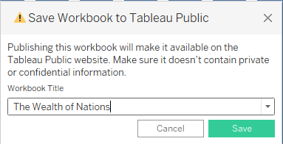

Once you have either created an account or signed in, this prompt will appear. Here this is where we want to name our project, this will display on Tableau Public for everyone to see so will have to put a name suitable for our project. I have named mine ‘The Wealth of Nations’. Once you have put a title press save.

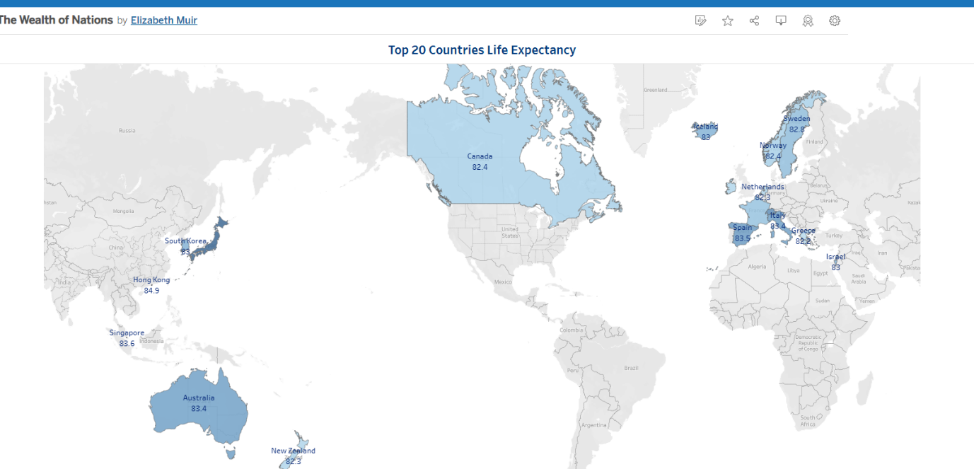

Give it a few moments to save your work. As a confirmation that your work has saved successfully, your map will now load in a browser. For now, when ‘The Wealth of Nations’ is searched this is what readers will see for now, we are now going to go forward and create another three charts and then our dashboard.

## Chart 2 – Top 20 Highest Raking Countries per GDP

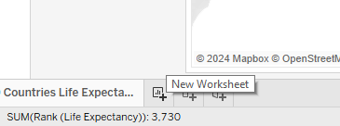

Head to the bottom of your page and click on the new worksheet button. This will load a new sheet ready to create our next chart.

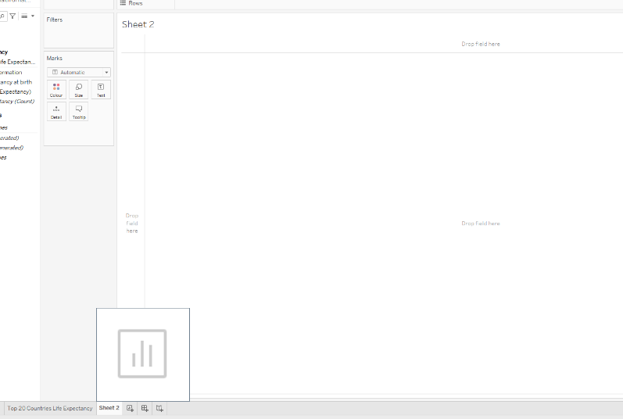

This is our new worksheet ready to work on. Firstly, we are going to put our title. Double click where it says Sheet 2.

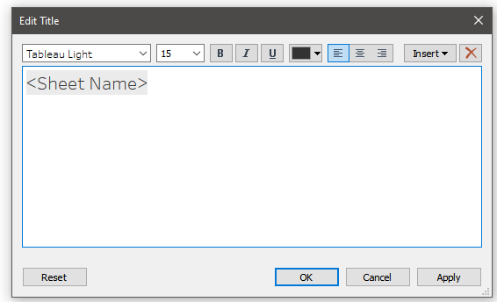

Our Edit Title box will open ready for us to change the text and format it the way we want. I am going to change my title to ‘Top 20 Highest Ranking Countries Per GDP’. I am keeping the formatting the same to what I have created because I want to keep my charts looking uniform and not out of place.

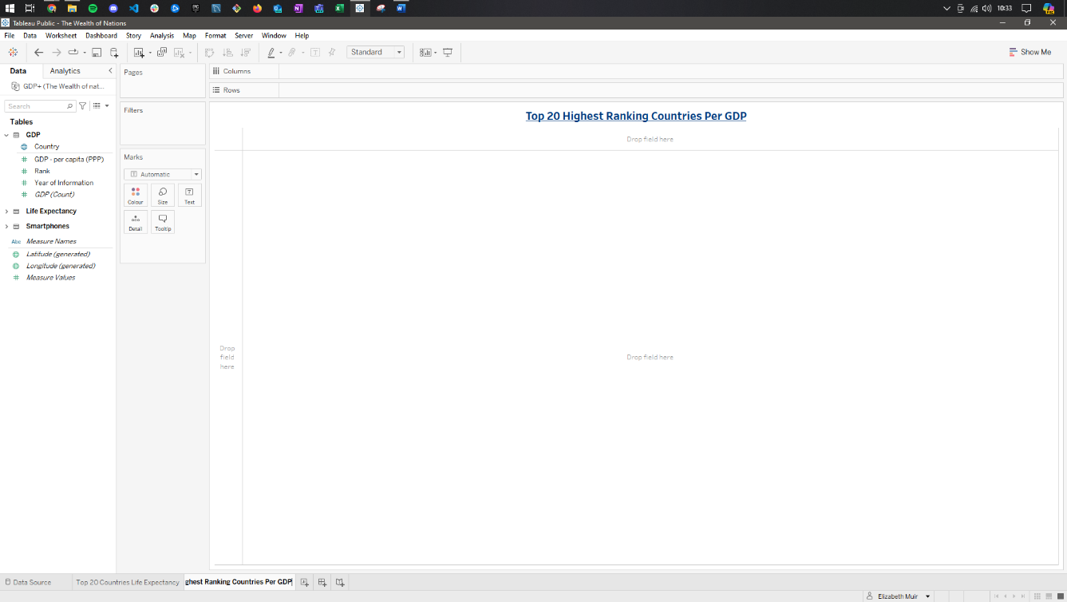

This is our title formatted to the way we want.

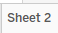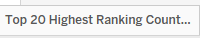

Before we move on with creating our next chart, we want to make sure that we rename our sheet to make it easier for when we make our dashboard.

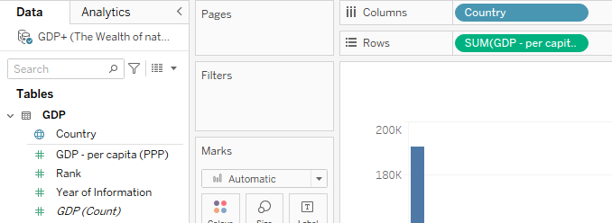

We want to head over to the GDP table on the left and select Country and GDP – Per Capita. Drag these over to the columns and Rows section and our chart will appear on our sheet.

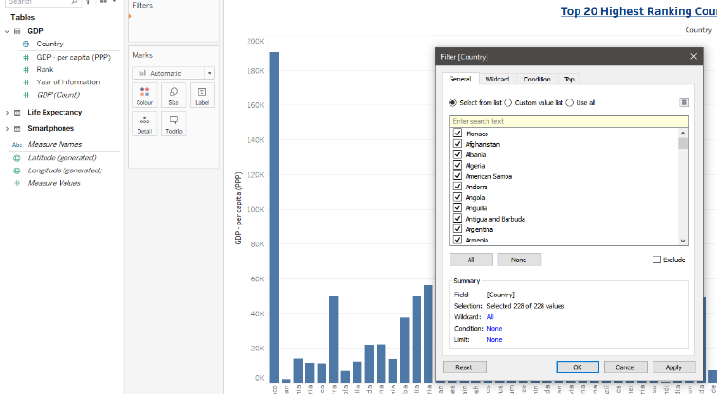

We need to put a filter on again to ensure that our chart is displaying the top 20. So, select Country and drag it over to filters to let the filter box appear.

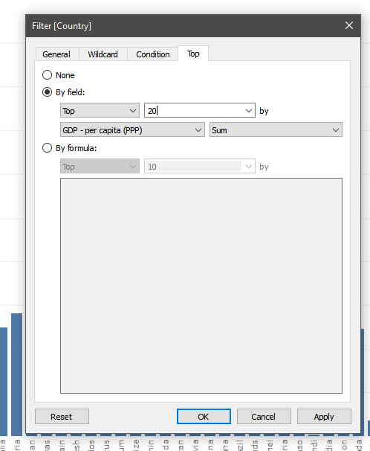

We now go to the Top tab and come down to the By Field selection and change ten to twenty. Once you have done that, select OK.

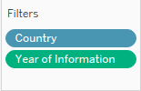

We also have to drag over Year of Information so that we can create a filter that readers can control the data that is displayed on the chart.

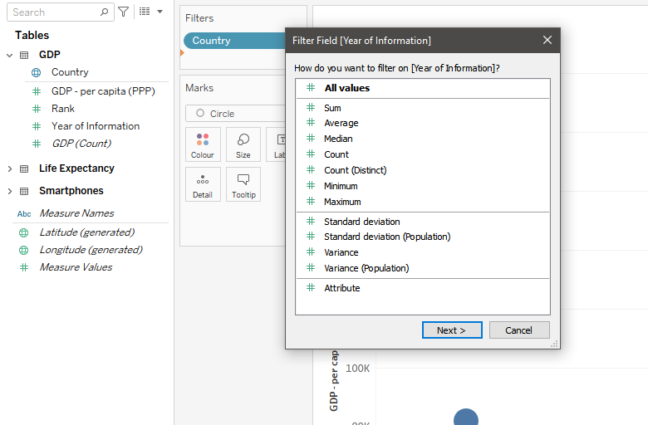

Once Year of Information is placed under filter, we have this box appear just refining what we want to show on our filter as we want to show all the years we will stick with all values. You can do other calculations like the average, median and count etc. Select Next.

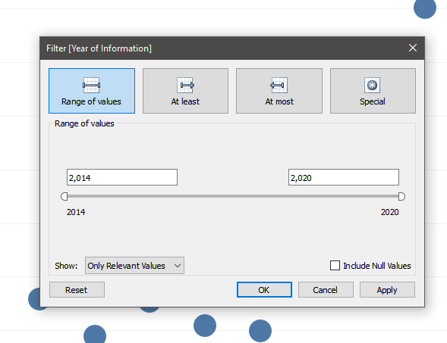

We then come on to the range. This is where you define what years you want to display. I am leaving this as is and selecting OK.

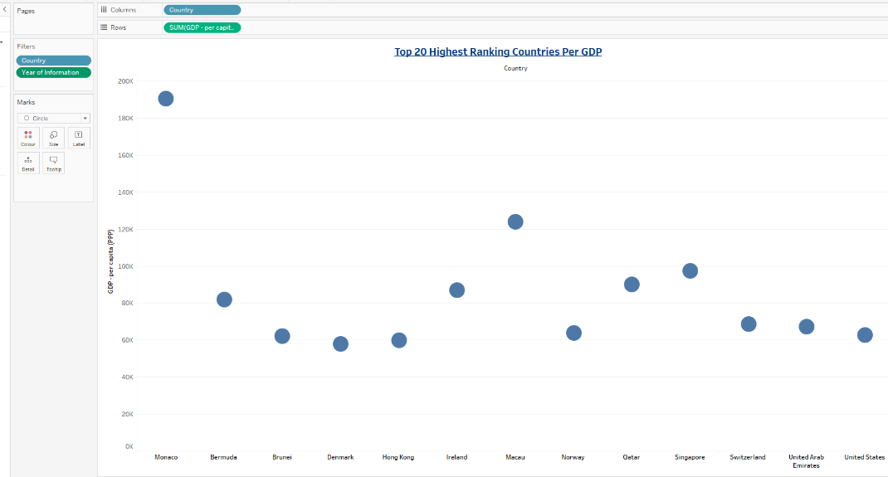

This is the chart as it is now we don’t see our filter box for us to navigate the chart.

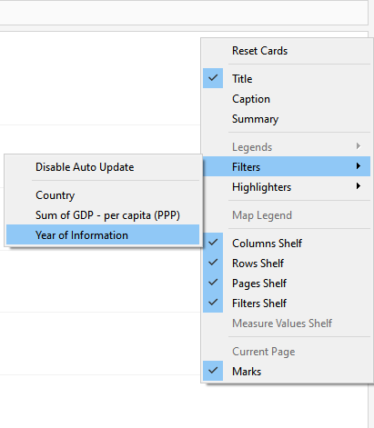

Under the marks section on the left side of our page we right click the blank area. Highlight filters and then select Year of Information.

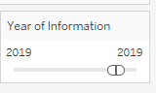

This will display our filter underneath the Marks section. For now, we have the year 2019 selected but if we wanted to add years or adjust to one year we do so with this slider.

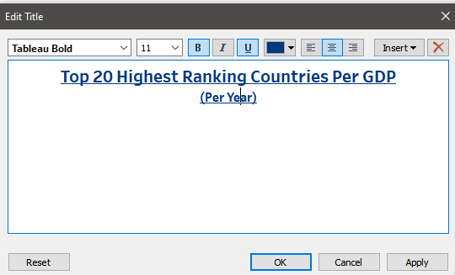

Before changing our chart, I want to add to our title ‘Per Year’ this is to tell the reader that it can be per year.

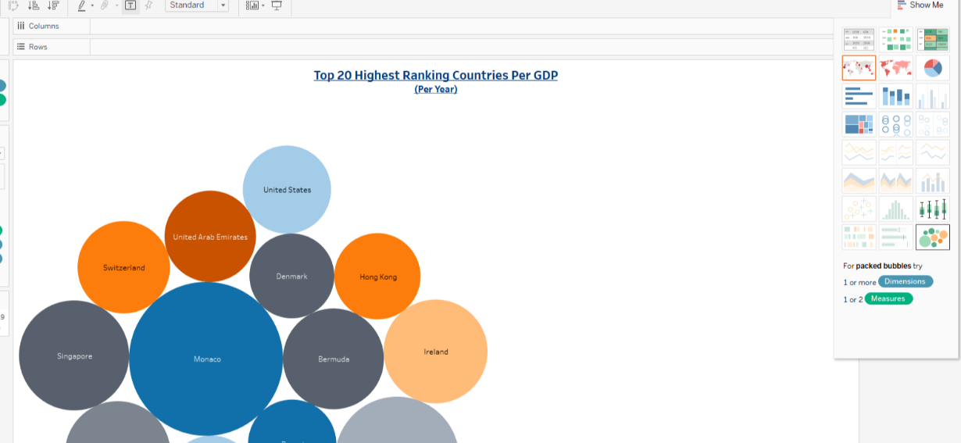

We want to change our chart design, again we come up to the top right and select Show Me, where the available charts will be displayed to choose from. For this chart I am going to select packed bubbles. Click here to change your chart.

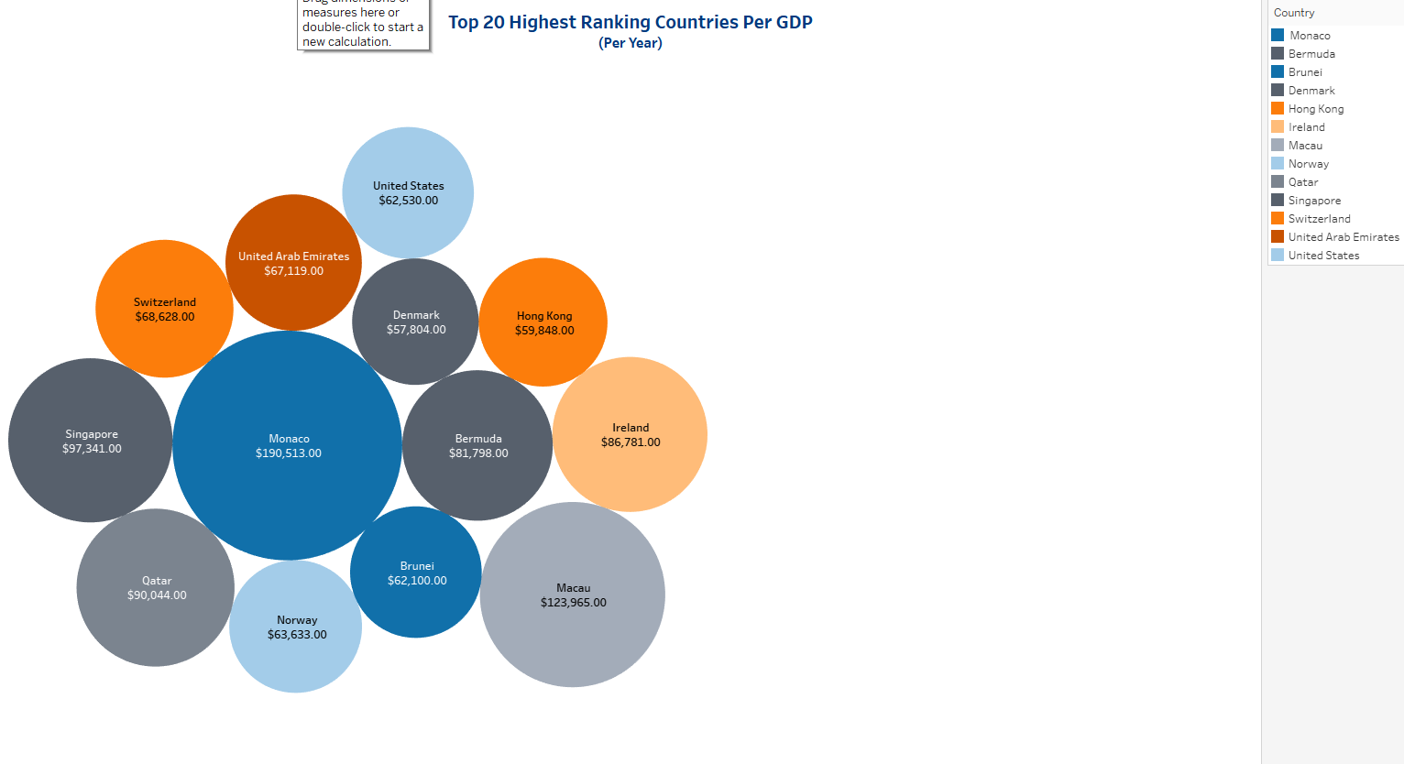

This is what my chart looks like once I selected packed bubbles. Only issue I have here is that my chart is far over to the left and I would like it to display centrally and more covering the screen.

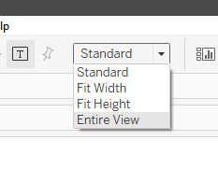

To position our chart a bit better we want to change the view of our screen. Currently it is set to standard, and we want to put it to Entire view. This view will ensure that our chart will display the best way possible on every sized screen that our readers use.

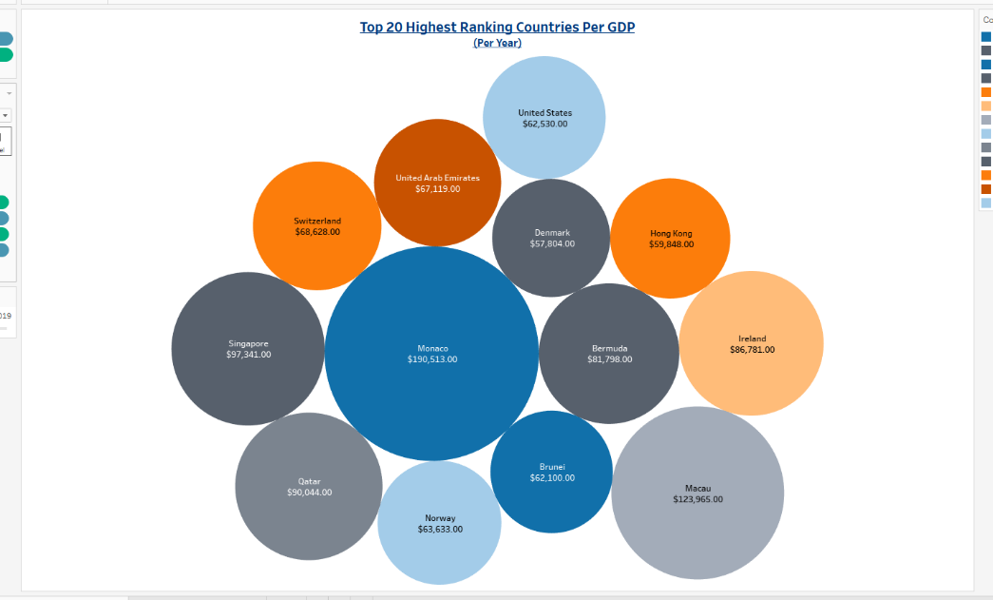

Now our chart is displayed in the centre and taking all available space it can. We just want to make sure readers can view our charts in the right way.

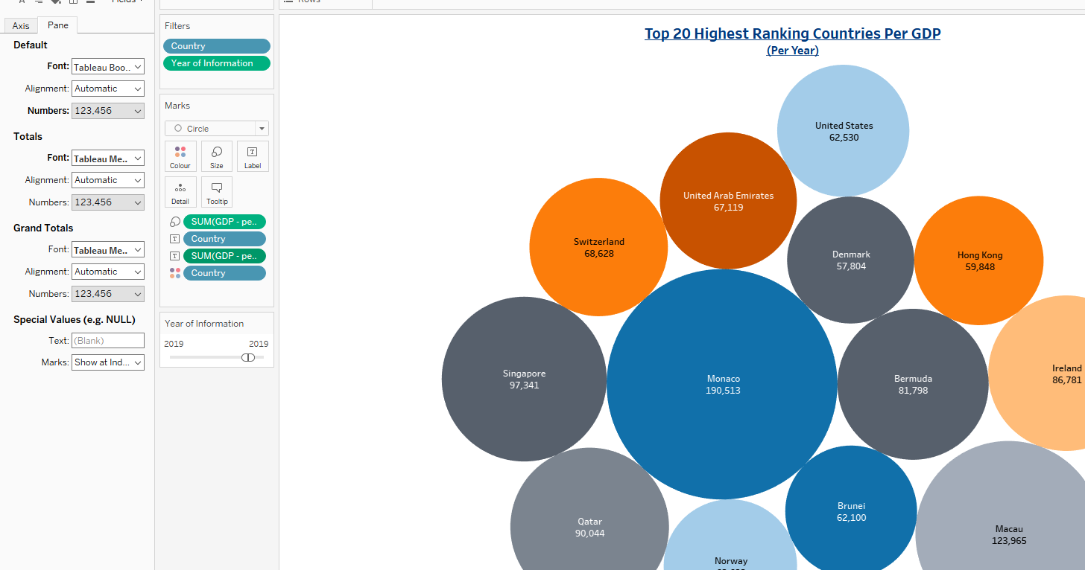

Time to format our charts. The first thing I would like to do is make sure that the countries and their GDP’s are displayed in the bubbles. We have to drag over the Countries field and GDP field to the label button. This will display the countries and their GDP in the bubbles. I want to also make sure that my GDP displays with a currency also, so I have to right click the GDP field with the text box and select format.

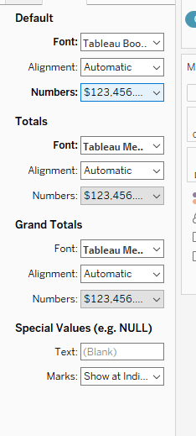

This will bring on the left side of the screen the format pane. Here we can change the font, alignment, colour, and the way that numbers are displayed. I am going to select numbers under default.

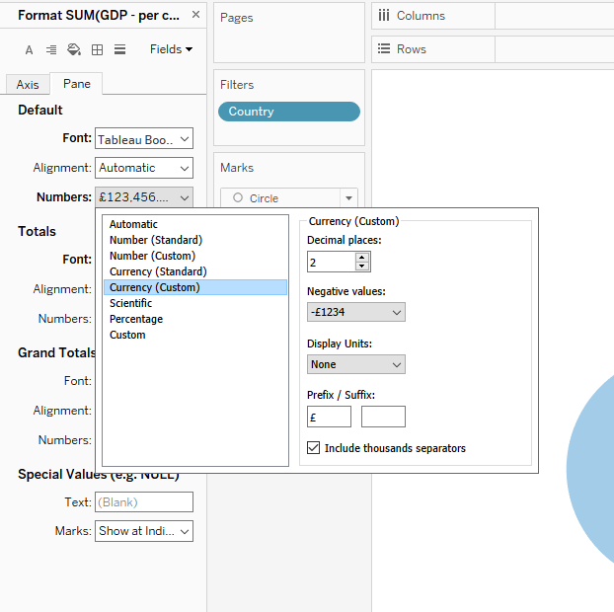

This will bring up options to pick from for how we want our numbers to be displayed, we can pick from standard or custom numbers, currency, scientific or percentage. I am going to select Currency (custom), here I can input what currency sign that I want.

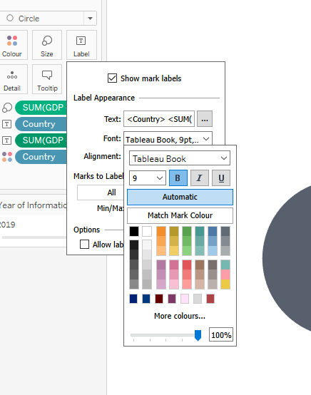

I am also going to add some styling to the font I am selecting bold to make it easier to read in each bubble.

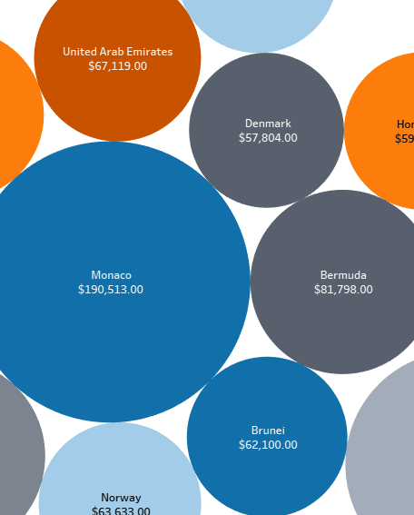

This is how the bubbles look once they have had styling and the currency added. I am keeping the colours of the bubbles as they match the specifications for colour blind viewing.

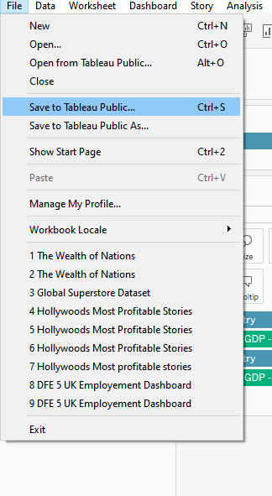

Now time to save. Again, we go to file and save to Tableau Public.

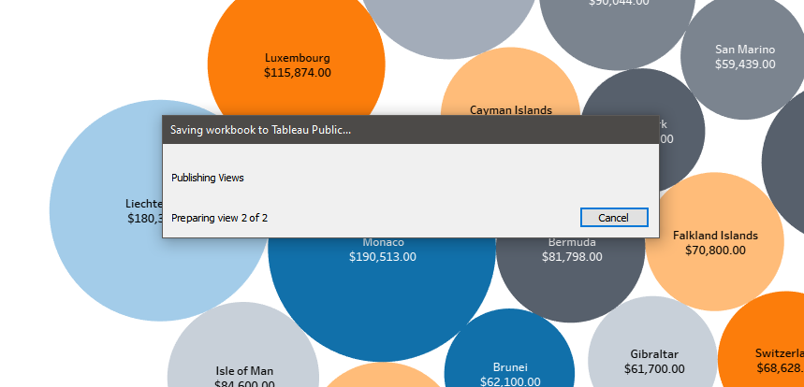

This box will then appear this is showing you that the process of saving is in progress. Normally this does not take too long to do.

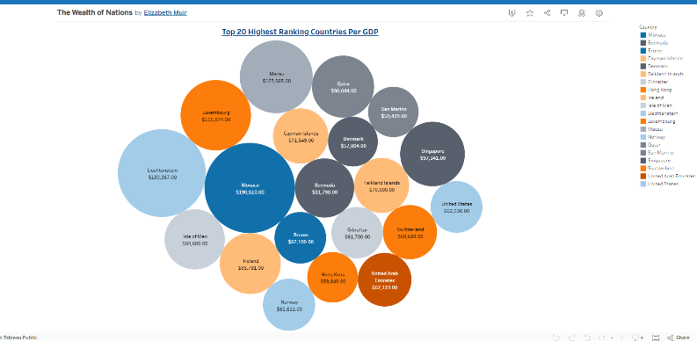

This is our confirmation that our sheet has been uploaded onto Tableau Public.

## Chart 3 – Top 20 Countries Smartphone Users

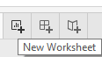

To start our new chart, we need to load a new worksheet. Go down the bottom left and select the new worksheet button.

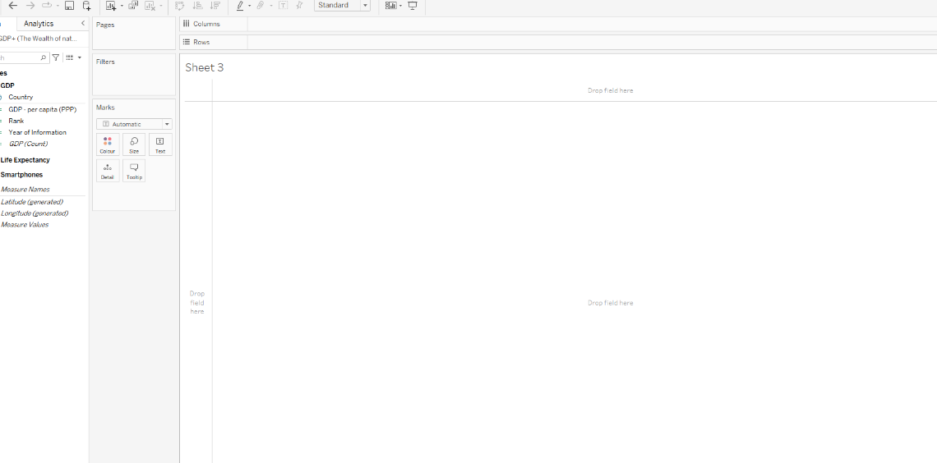

Our new sheet loads up ready for a new chart. Double click where Sheet 3 is and set a title.

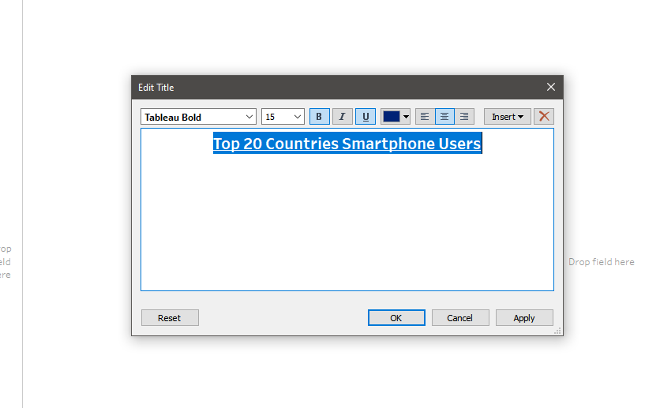

Choose your formatting that you would like for your sheet. Here I am sticking to the same format I have used with the previous sheets. Making the font bold and underlined with a dark blue colour. I have also aligned the title to the centre. Once done select OK.

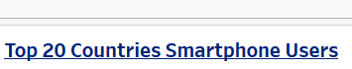

Here is how our title looks on our sheet.

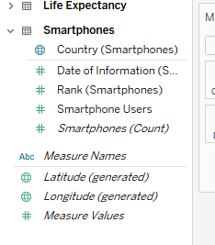

For this chart I am selecting the Country and Smartsheet Users fields, click and drag them over to where our rows and columns are.

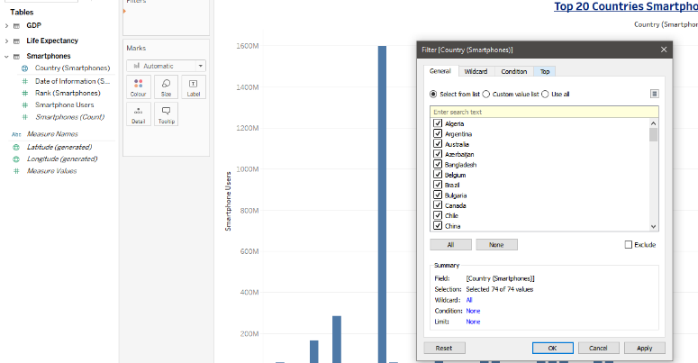

Before formatting we have to set our chart to display top twenty as this is a requirement set by the client. Drag Country to the filter box and the filter prompt will appear.

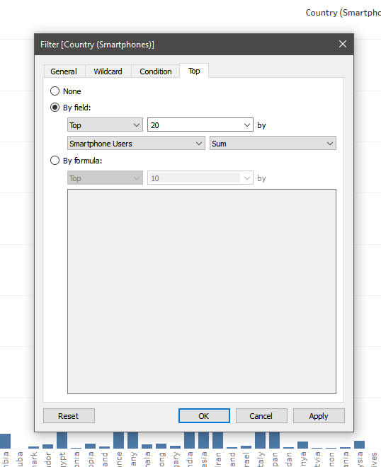

Selecting the top tab we want to put in twenty instead of ten then select OK.

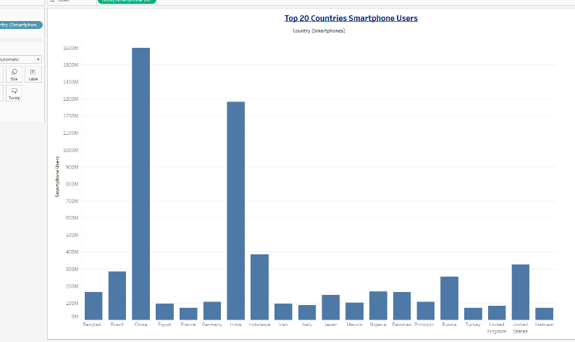

Now the bar chart is showing the top 20 countries.

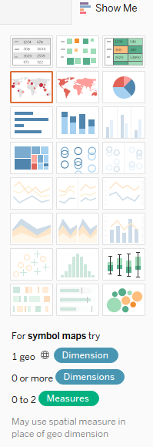

Now I am going to change my chart to another design. Go up to the top right-hand corner and select Show Me. The charts that are available for our data are highlighted here. For this chart I want to use a tree map which will measure using squares.

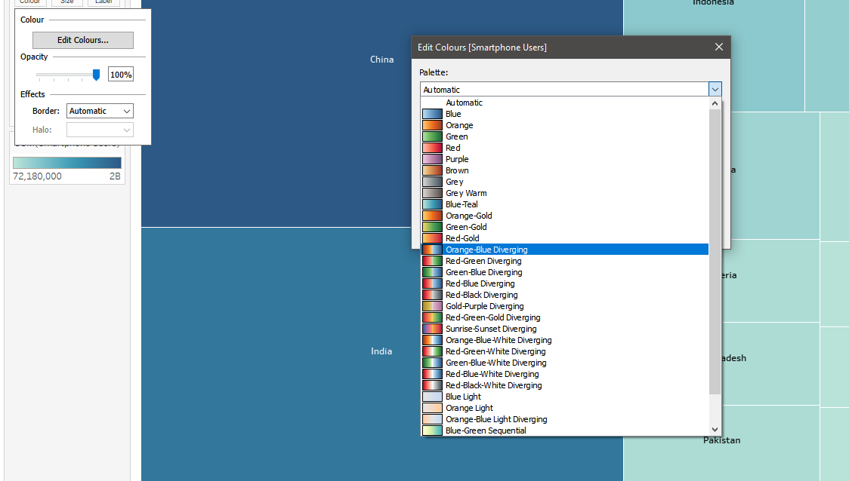

Once we have selected our design, we want to make the colours suitable for readers. On the left side under marks, we want to select colour and then edit colours. This will bring up the colour prompt box. From the drop down we want to select a colour suitable for colour blind readers. I have selected Orange-Blue Diverging. This puts a couple of colours into the mix to make our chart readable compared to one.

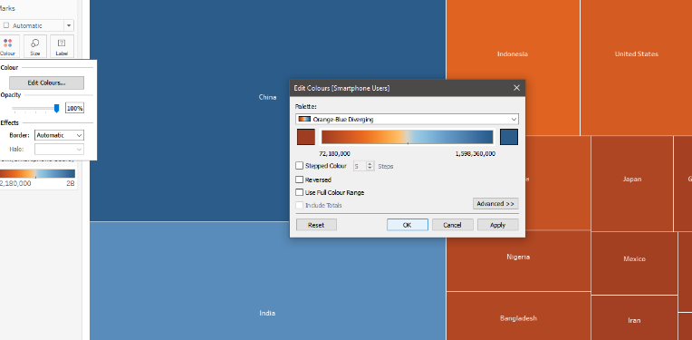

Once I have selected the colour I can go ahead and press OK.

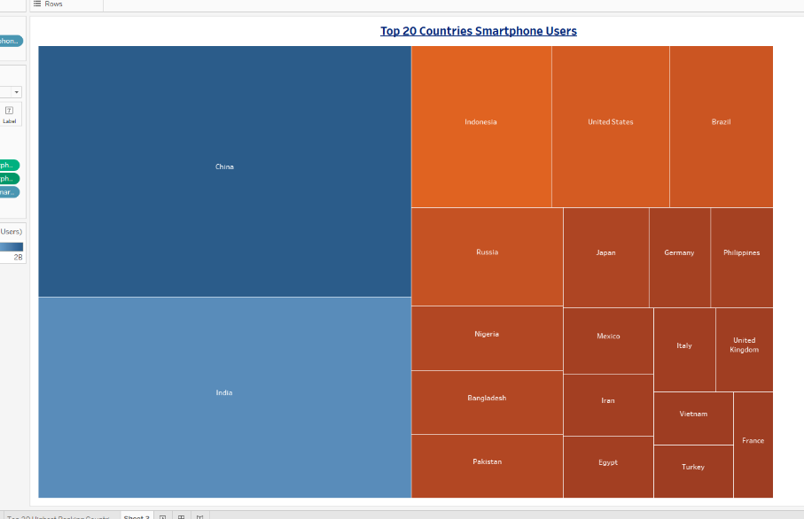

This is how the chart looks now.

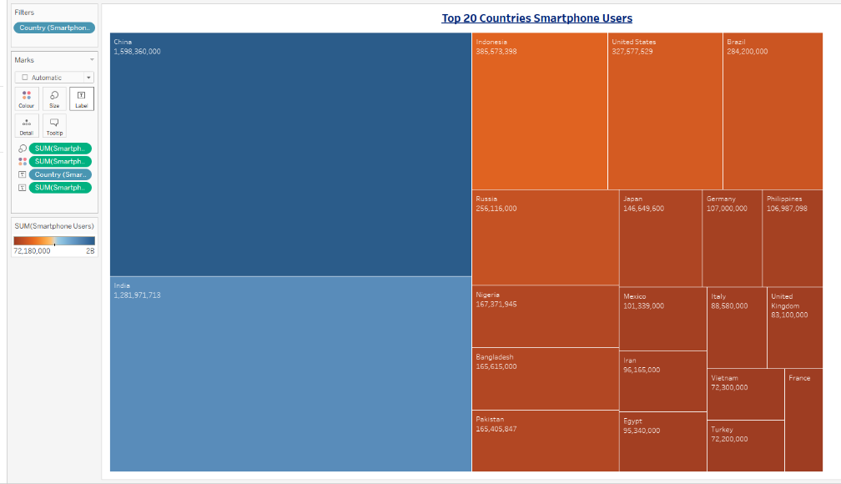

I want to add to my chart. I am going to add a label with the amount of smartphone users per each country. To do this I select the smartphone users’ field and drag it to the label box under the marks section.

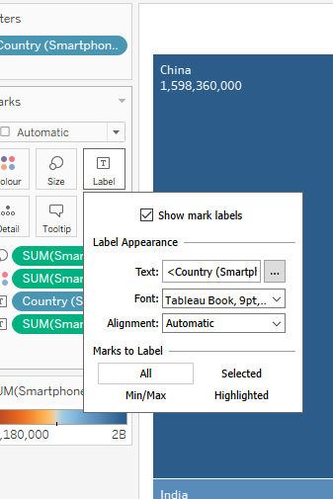

Now we want to format these labels. We go to the label box and select it. This will bring up our options to format. I just want to put a boldness on the labels, and we can do that under font.

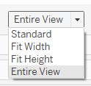

Once we have formatted our labels, I want to display my chart to fit the entire page to suit every monitor. Head to the top of the page and select the dropdown box and select the Entire View option.

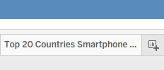

Before we go ahead and save, we want to rename our sheet. Head to the bottom of the page and double click sheet 3 and put in a title. This will help us when it comes to creating our dashboard.

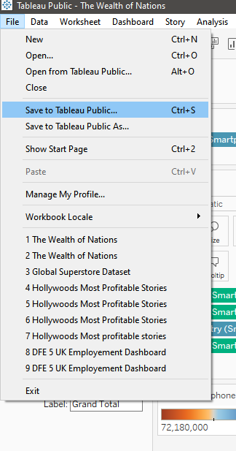

Go to file and then save to Tableau Public.

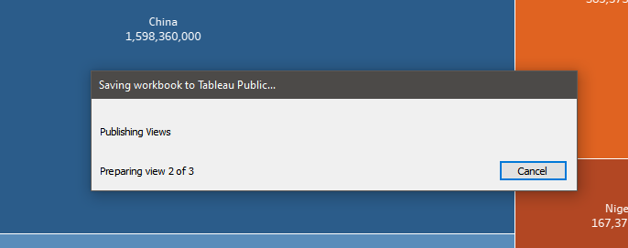

The saving progress bar will appear showing the progress of our sheets saving and publishing onto Tableau Public.

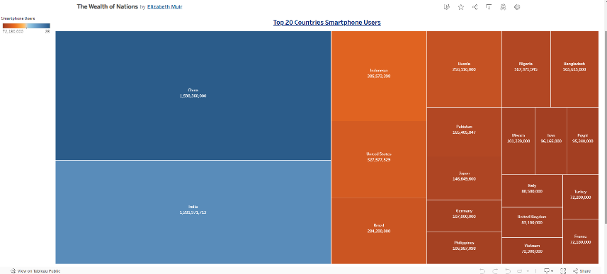

Here is our confirmation that our sheet has been published successfully.

## Chart 4 – Top 20 Ranked Countries Life Expectancy



For our final sheet we go to the bottom and select new worksheet.

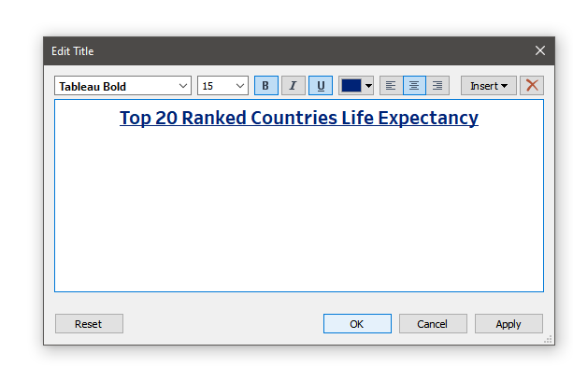

Double click where sheet 4 is displayed on the top of our sheet. This will display the format title box. Again, following all the previous charts, I am going to put my title, change the font weight to bold and underlined, align to the centre and change the colour to dark blue.

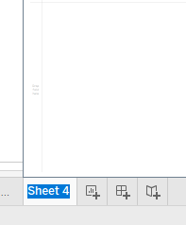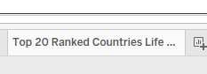

Before commencing our final sheet, we want to change the sheet name. Come to the bottom of the page and double click sheet 4 and change the title. Again, this will help when we create our dashboard.

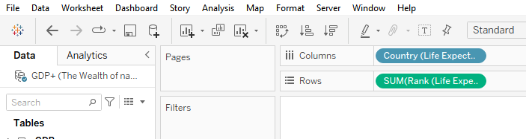

We are going to take Country and Life Expectancy and bring them over to columns and rows ready to create our chart.

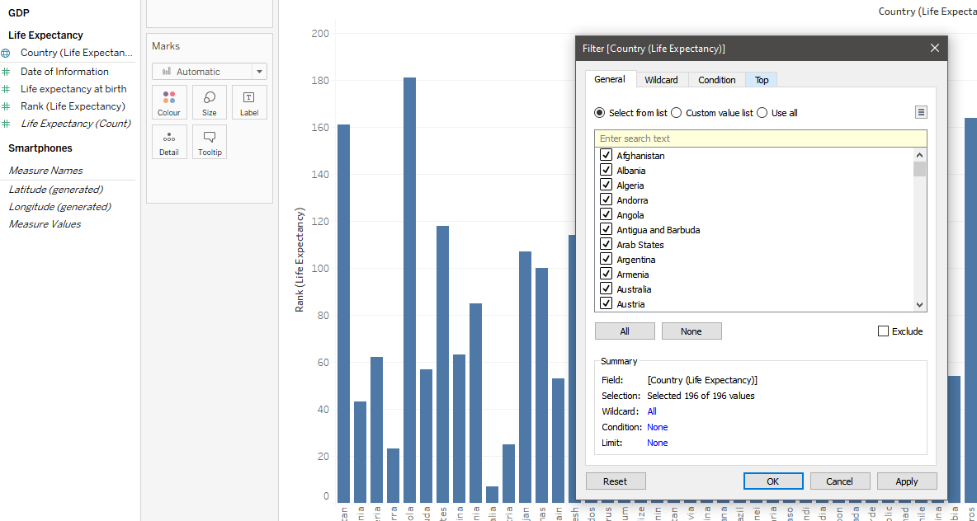

We need to filter our chart. Drag country over to filters and our box appears.

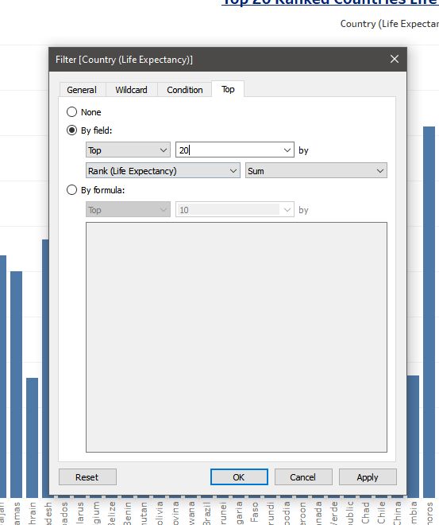

Head over to the top tab and again here we are turning the ten to a twenty to display the top ranked countries. Select OK.

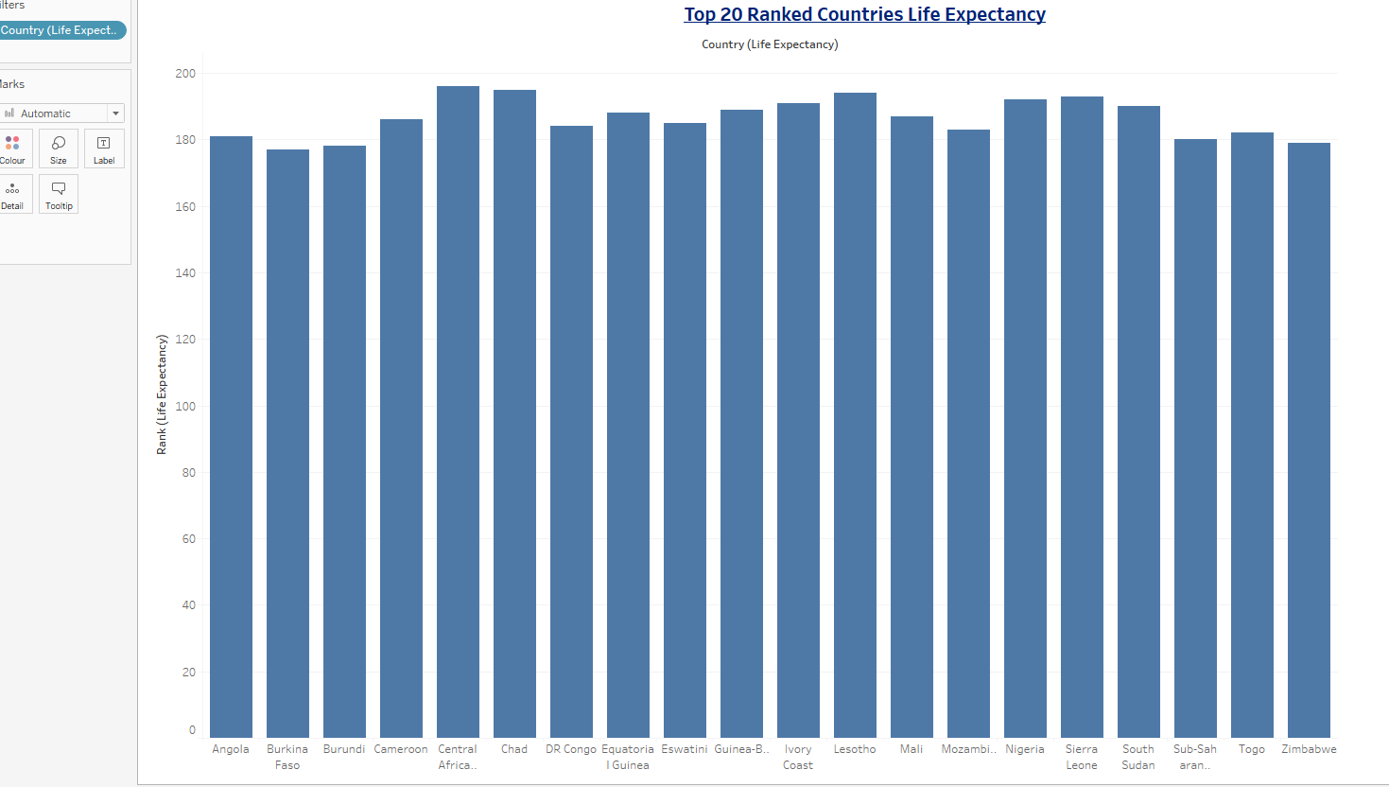

Now here we have the top 20 ranked countries displayed.

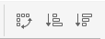



For this chart we are going to make the bars all sort from lowest to highest. Above our chart area we have these three buttons that are used to sort from highest to lowest and lowest to highest. We also have an option to change the way the rows and columns are displayed instead of them going from bottom to top we can change the position to go left to right. For now, I am selecting the middle button to display from lowest to highest.

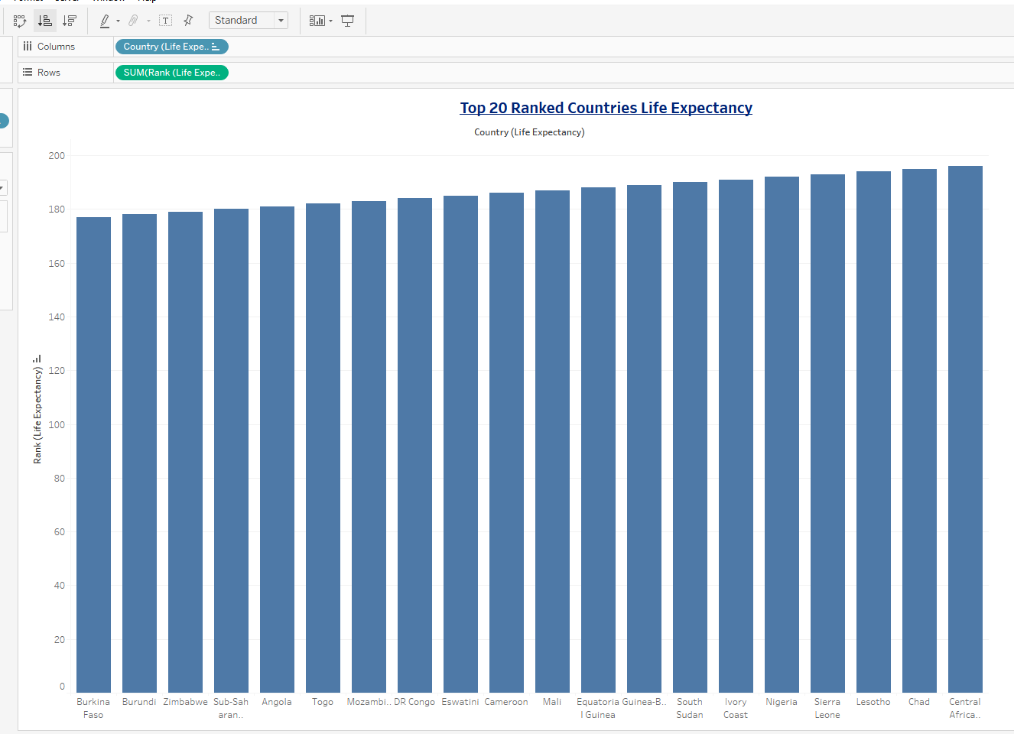

With our chart sorted this is how it is looking now.

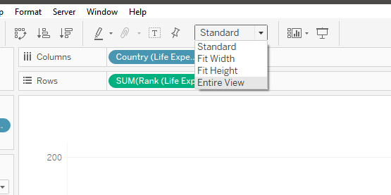

I am now going to make the chart take up all the space on the page making sure it is viewable on all monitor sizes from readers. Select entire view.

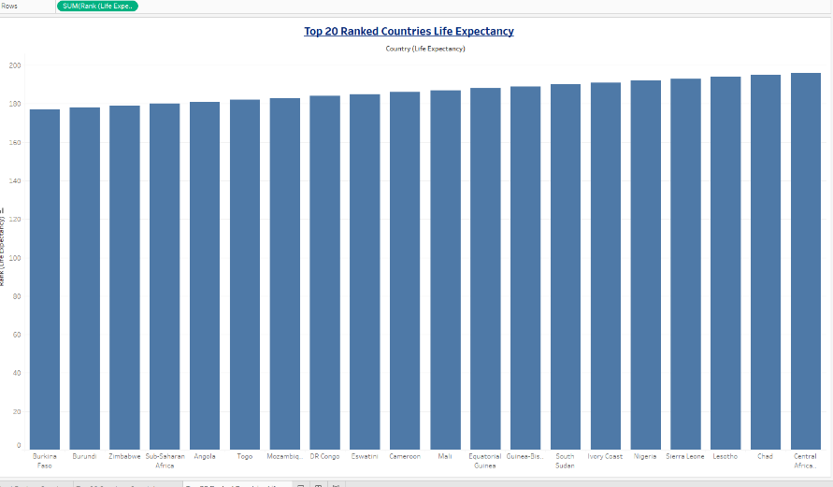

You can see the white space to the right is now taken up by our chart.

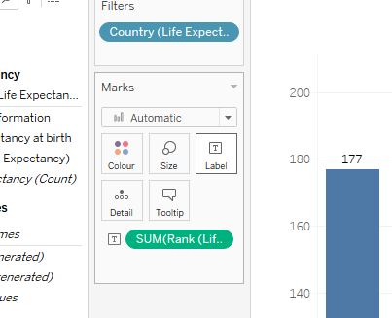

Now I am adding some labels to the bar chart. I am going to select Rank from the Life Expectancy table and drag it to the label button. This will then put the value at the top of each bar.

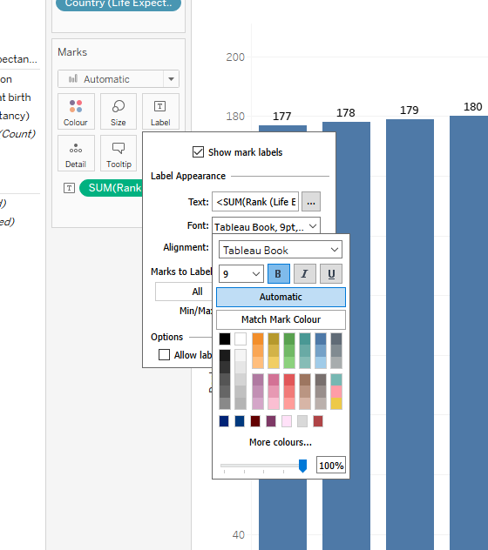

I am now going to style these labels. Head to the label button under the Marks section and the format box will appear. I am going to make the font bold.

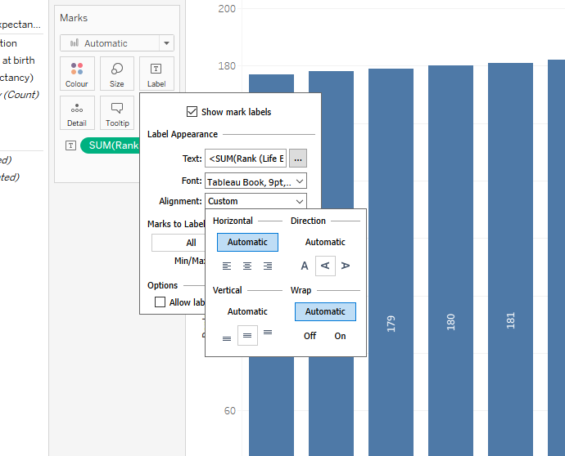

Under the alignment I am making the text turn direction so that it can sit in the bars and centrally.

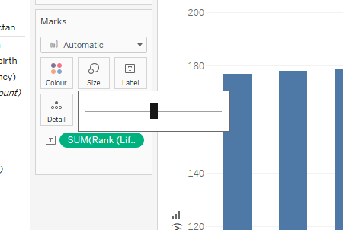

Now I am going to slightly adjust the size of my bars. This option is under the size button of the marks section. This bar line will allow you to make the bars smaller or larger.

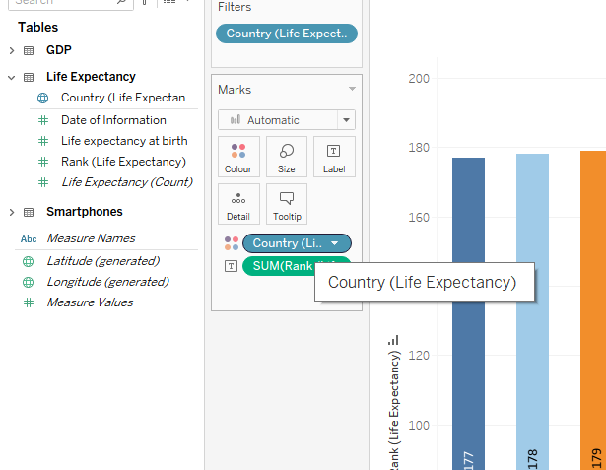

Now I am adding some colour to the bars. As the country field is not selected, I have brought over the field and drop it on colour.

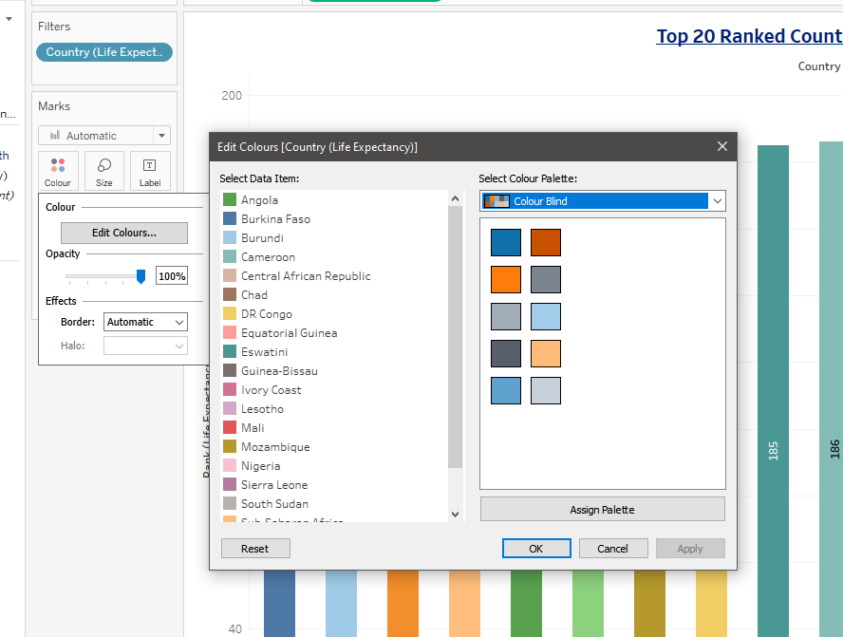

Now I can select colour and the options box will appear. This box is a bit different compared to other charts that I have created. This is because you can colour each bar a different colour if you would like. I am going to select the palette and select the colour-blind option that is already available in Tableau. As I have so many different countries, I would not be able to have a single colour each for them but that is ok because I want to make sure that the colours are suitable for the readers that are colour blind. Once selected press OK.

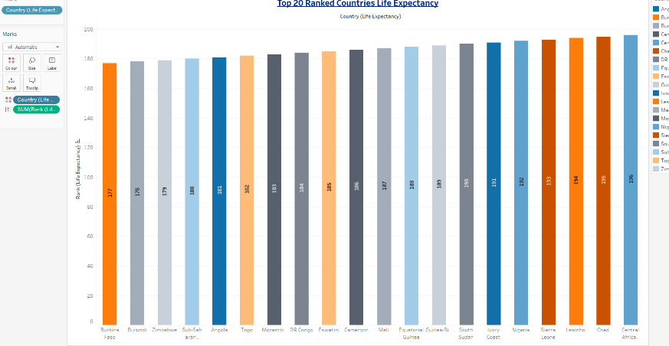

This is how my chart looks now.

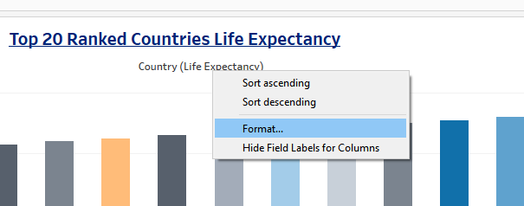

For this chart I am going to do more formatting to show you what Tableau is capable of. I am going to first change the axis titles. I have right clicked Country and going to press format.

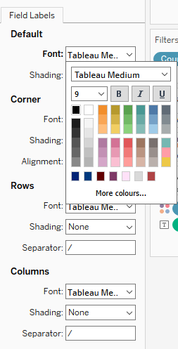

At the left-hand side of our page the format panel appears. We want to go under default, font and then select bold and dark blue.

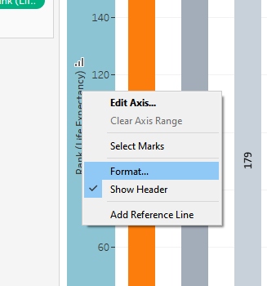

Now I will format the y-axis. Right click and press format.

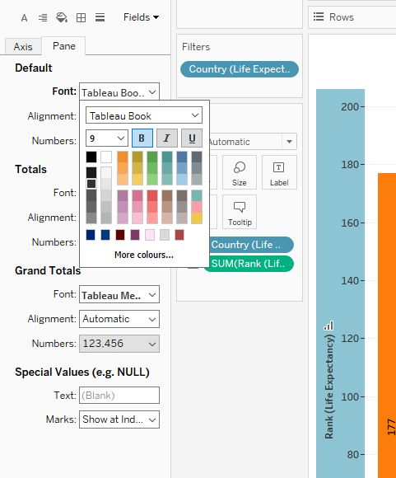

Again, the panel will open for us to format. Under default font I am going to select bold.

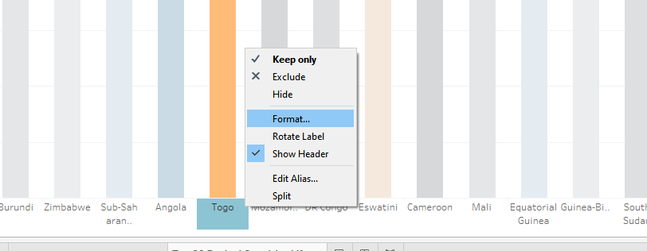

Then for the bottom where the countries are right click and press format here.

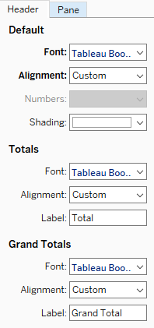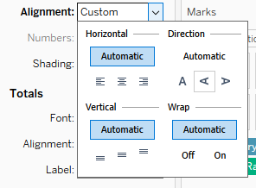



For the countries I want to make them bold but also change the direction of the countries to sideways. So, we have to select alignment and under direction select the middle option.

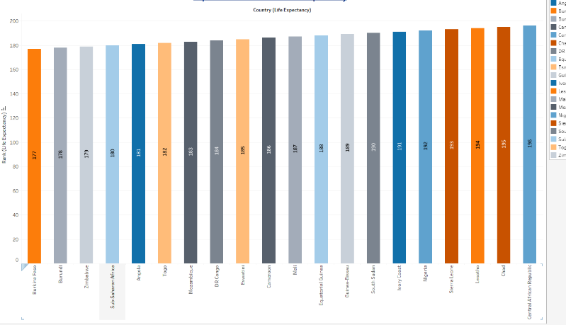

You can see that the countries are now displaying sideways that makes it easier to read and not all jumbled up when they are displayed left to right.

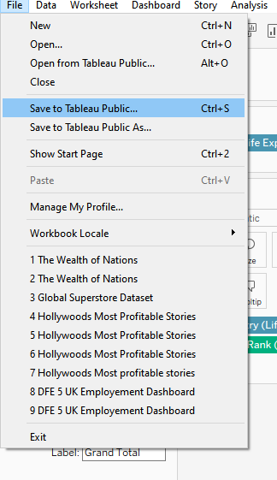

Now it is time to save our final sheet. Go to file and save to Tableau Public.

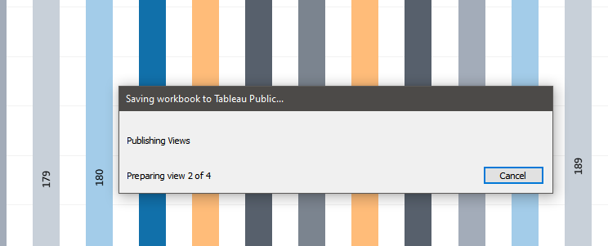

Our progress box appears.

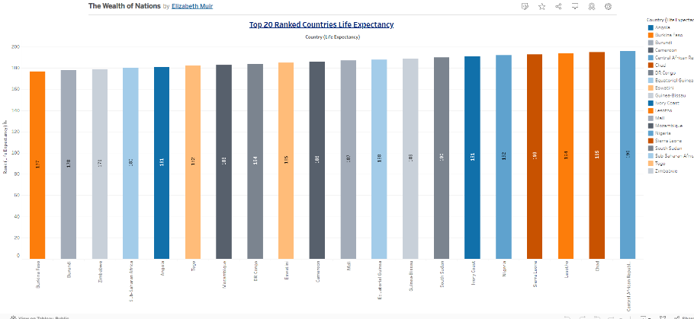

Confirmation of our chart published to Tableau Public will appear in a new browser.

## Wealth of Nations Dashboard

We are going to create a dashboard showing our charts. The main use for a dashboard is to show an overview of data from different sources at one time. In our case here from our four charts that we have created.

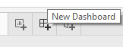

Now it is time to put all our charts together and create a dashboard. Go to the bottom of the page and select New Dashboard. This is the icon next to the new sheet button.

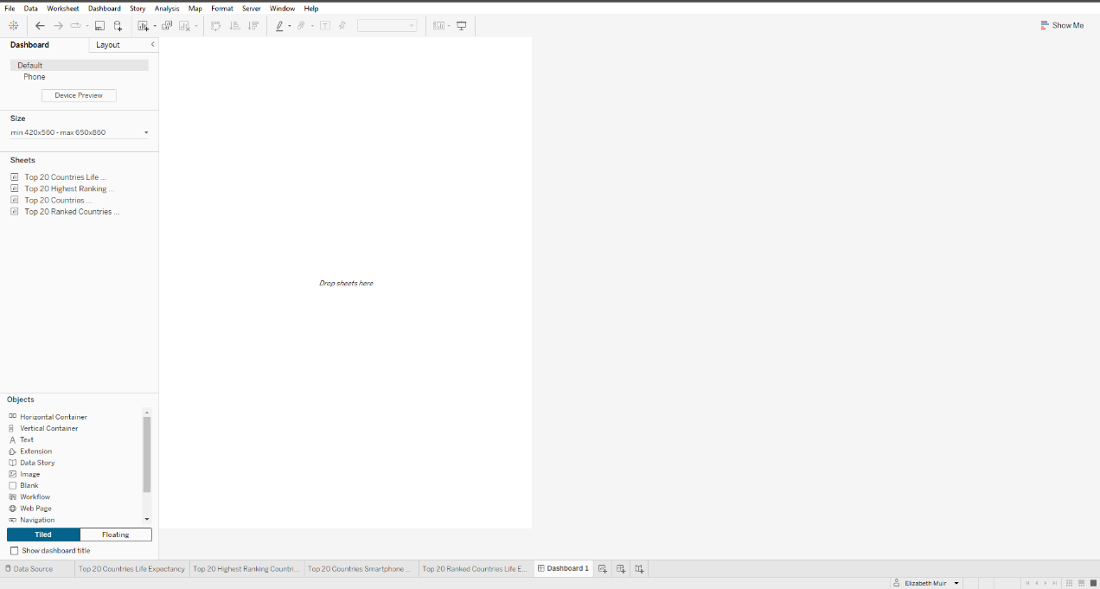

This is our dashboard page. This is where we are going to add all our charts and other features and position them in an easy to read way.

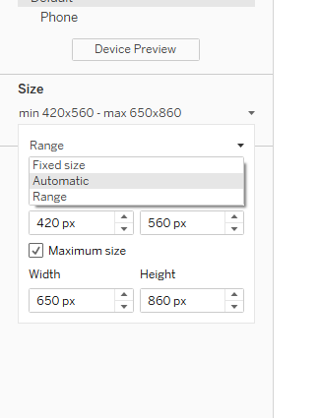

To start off with we must change the size of the page so that we can have to most space available to put our charts on. On the left-hand side under size we want to select the drop down box and select Automatic.

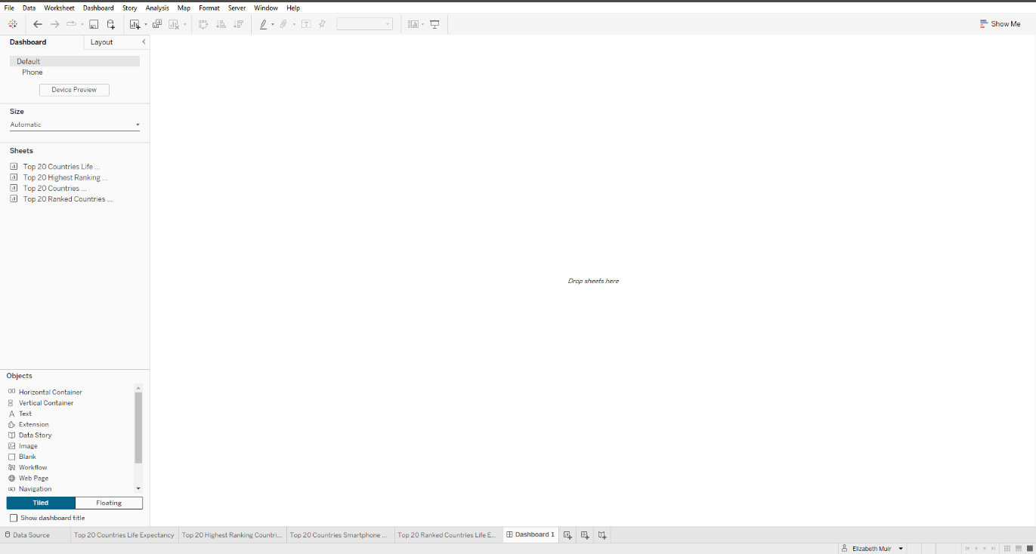

Now you can see that the screen has gotten larger and gives us a bigger canvas to play with.

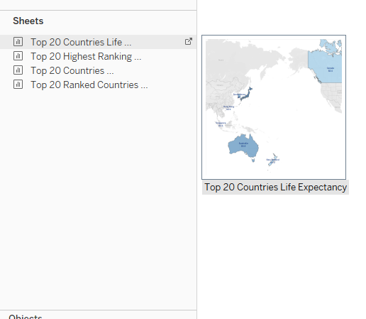

This is where we start putting our charts into place. On the left under where we just selected size, we can see all our sheets that we have created. As mentioned previously it was important to name each sheet as we can now define each sheet that we have created. A lovely thing Tableau includes is a little snapshot of how our chart looks so you can understand further what one you are going to select to put into place. Firstly, I am going to select the sheet top 20 countries life expectancy. We then drag this sheet onto our canvas.

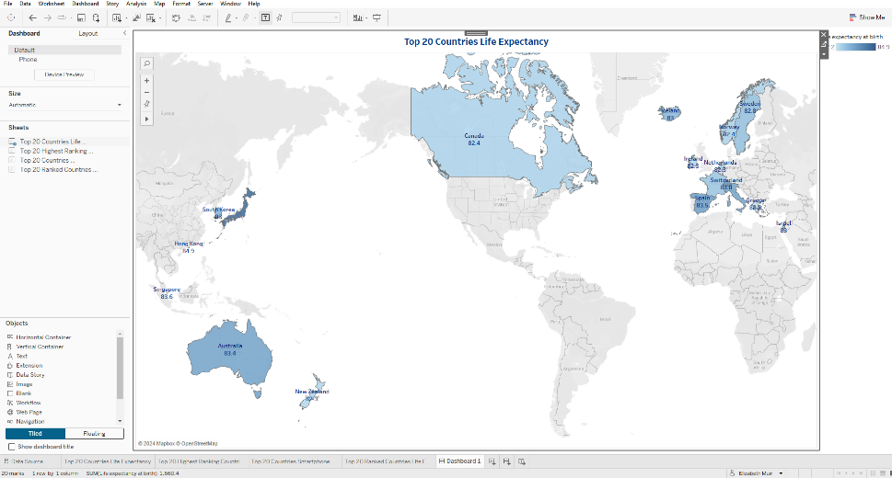

There we are, we have successfully added our first sheet to our dashboard. At the moment it takes the whole page up, but as we start adding each sheet, we can position them in a way that we like and adjust the sizes as we go.

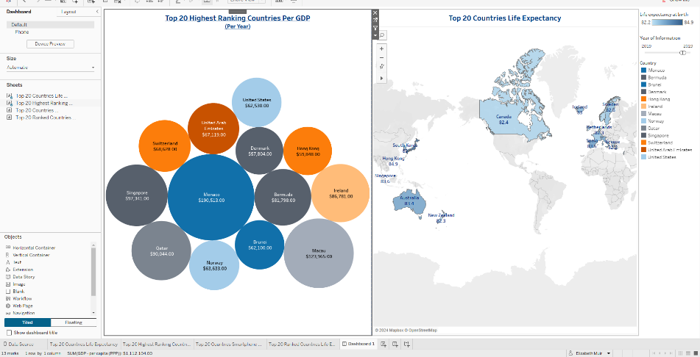

We are now going to select top 20 highest ranking countries per GDP. Click and drag this over to the left side of the canvas. You can see that adding this sheet it has moved our first sheet over to make space for it.

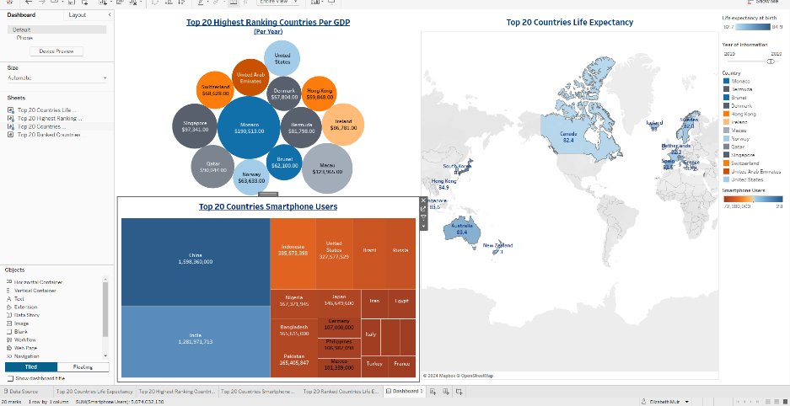

Now we are going to bring sheet three in. Go to top 20 countries smartphone users and click and drag this sheet to the bottom of sheet 2. Again, here the sheets are making space for one and another and adjusting to their spaces.

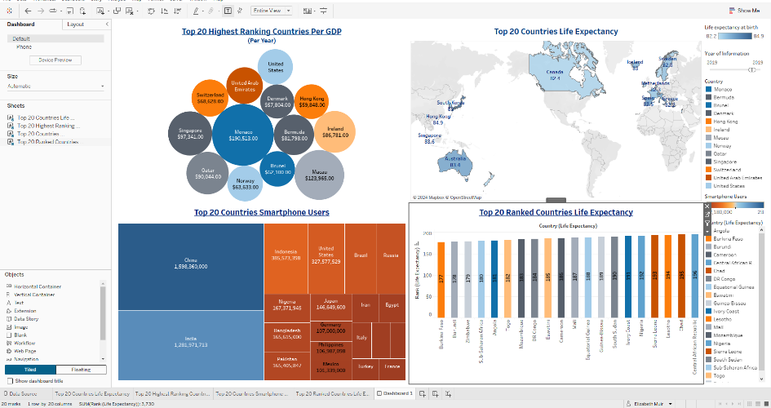

Lastly, we want to bring our final sheet over, select top 20 ranked countries life expectancy and click and drag it over to the bottom right corner and you can see that it sits in there with the other sheets giving it space.

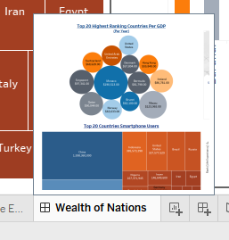

Now before moving on, we want to make sure we title our dashboard. Like we have done with our sheets we come to the bottom and double click the dashboard sheet name and change it to what we want. I have called mine ‘Wealth of Nations’.

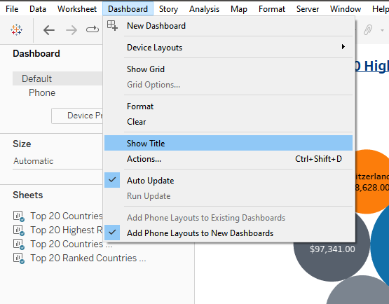

Time to start organising our dashboard. We want to add a title, and this is where our renaming of our dashboard sheet comes in handy. Go to the top and open the Dashboard menu item and select Show Title.

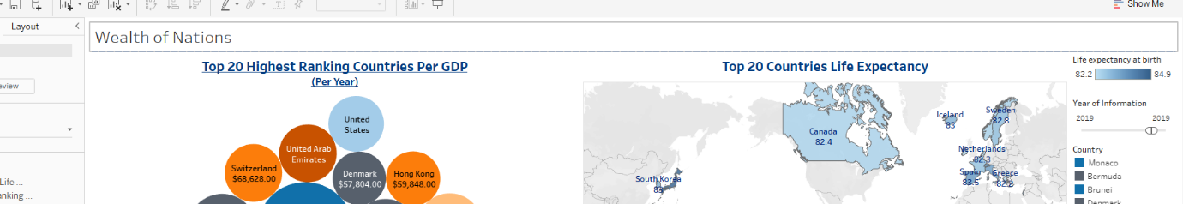

And there it is. Our title appears at the top of our charts. You can see that our rename of the sheet has become the title of our page also.

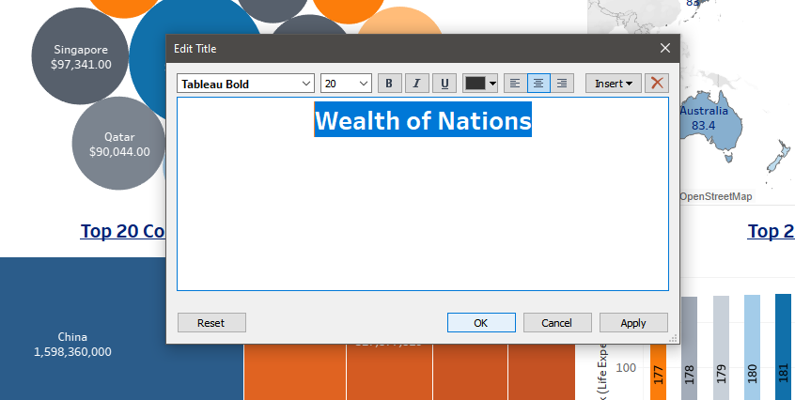

Now for a bit of formatting we are doing the same process that we have adopted when we created our sheets. Double click the title and the format box appears. Here I want to make the font bold, size 20 and aligned to the middle. Once I have completed that I select OK.



We can see now that our title has been formatted and displays in the centre and a bit bigger to what it was.

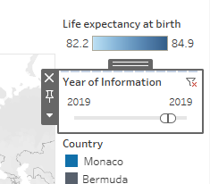

On our right side of our dashboard sheet, we can see all the different keys and filters that have been created with our sheets. One being the Year of Information. We want this to display with our chart so that readers can understand that it works with that chart and wouldn’t feel confused. Select this filter.

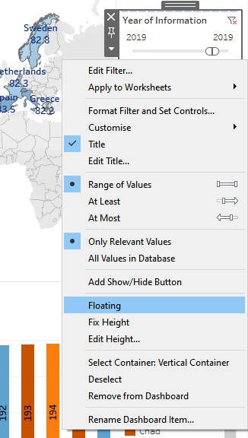

Right click it and select floating. This is going to make this filter box floating so that you will be able to position it wherever you feel necessary.

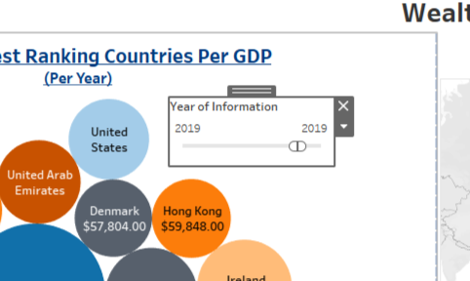

I have now dragged it over to the top 20 ranking countries per GDP chart. This will give the reader opportunities to play with the chart and display certain information that they want for that chart.

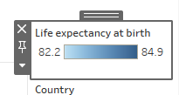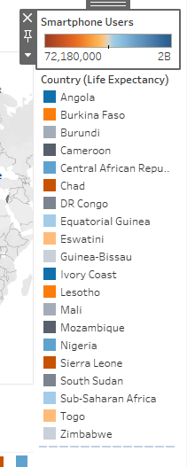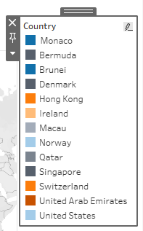

Now for the other keys that have been created, we want to remove them as every chart is labelled ready to read and we won’t need the keys to do the same job. To remove them we must select the key.

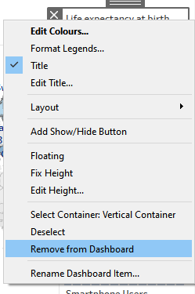

Then right click and select remove from dashboard. I had to do this one by one until all the keys was removed.

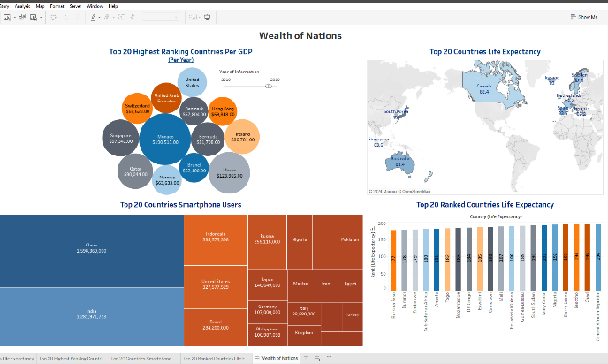

Now this is how our dashboard is looking.

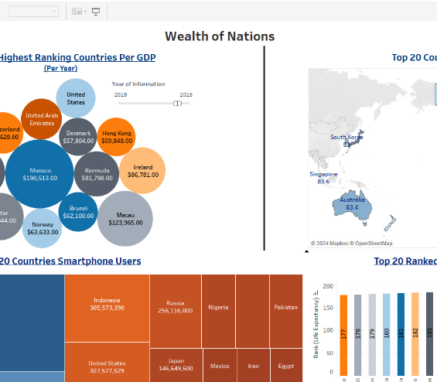

I now want to start positioning our charts a bit a better so that I will be able to add other features to explain the dashboard.

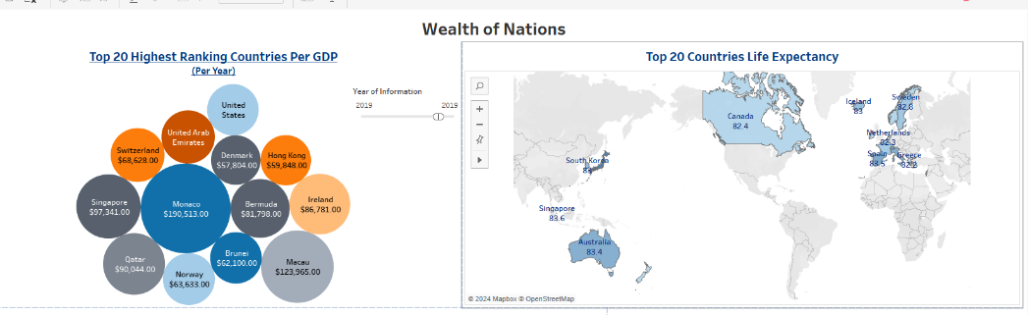

As you can see here, I have moved the first chart over a bit to the left as we have a lot of white space on it that we don’t need.

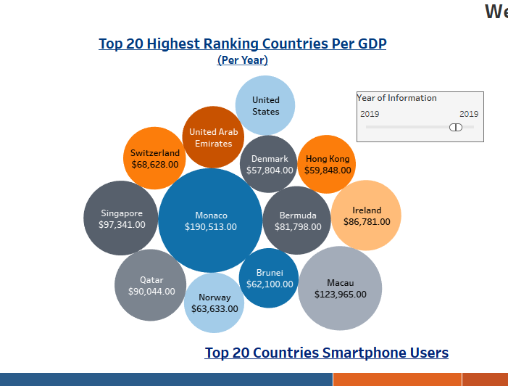

I now must move the filter box over a bit more to display better closely to the chart it represents.

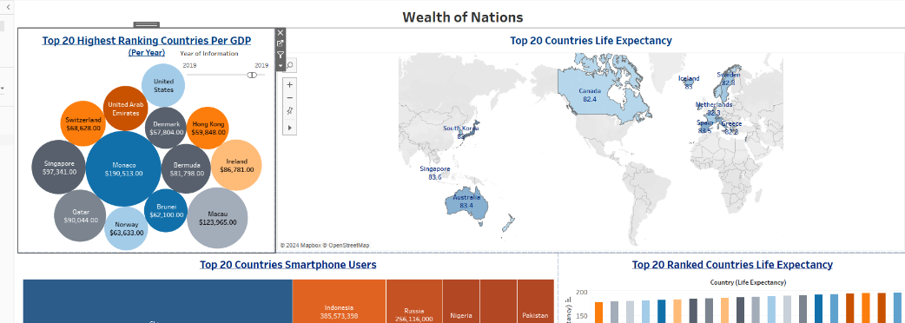

This is how the first 2 sheets are looking now. I want to add a box in between them so that I can add some information about our dashboard.

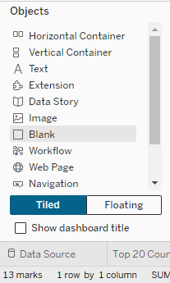

At the bottom left of our page we have an objects box with a different number of features that we can add to our dashboard. I am going to use a blank box for now to help with the spacing that I need between our first two charts. Click and drag Blank to our canvas.

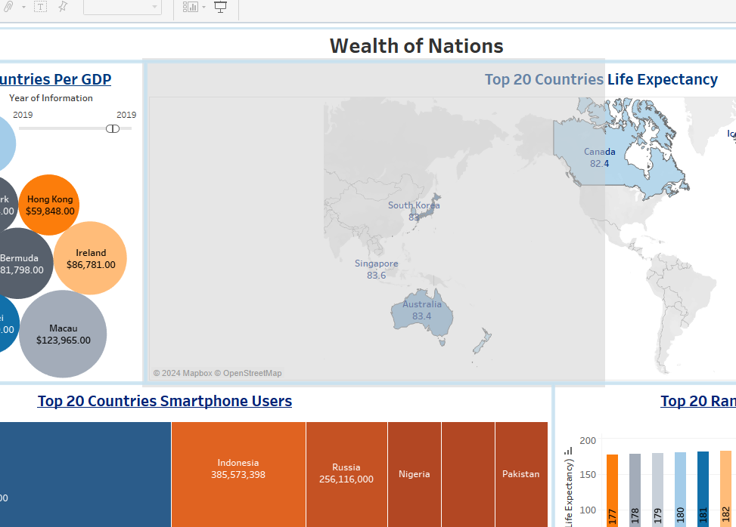

This is what the canvas will look like when you drag the box over allowing you to position it in between the first two charts.

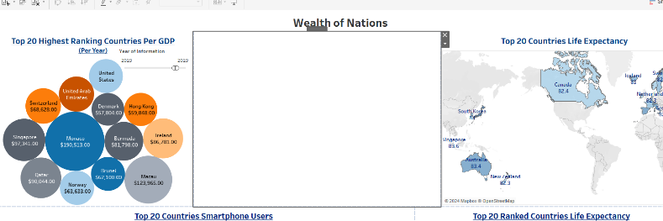

This is the box as is when we release it on the canvas, as you can see, we need to do some tweaking to it to make it look better positioned.

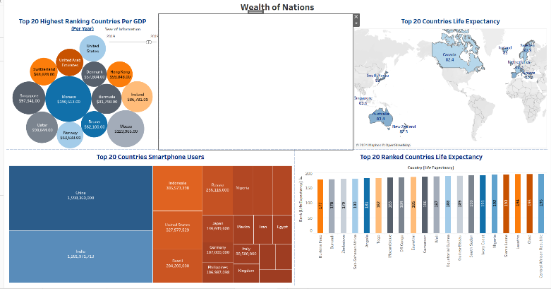

I have resized the box a bit to make it a bit smaller.

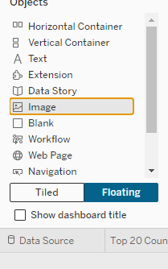

I now want to add another object into the box. I first have to select the floating option at the bottom. This will allow me to select an object that can be easily moved to where I need it. I am going to add in an image. Select image.

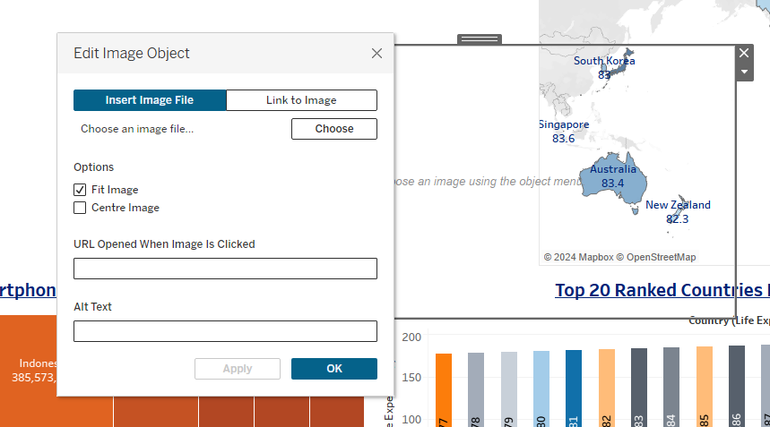

Once you have dragged image over to the box and edit image object prompt will appear. This gives you the options of adding your picture either from file or an URL. I have already got an image stored on my PC, so I am going to select choose to browse for it.

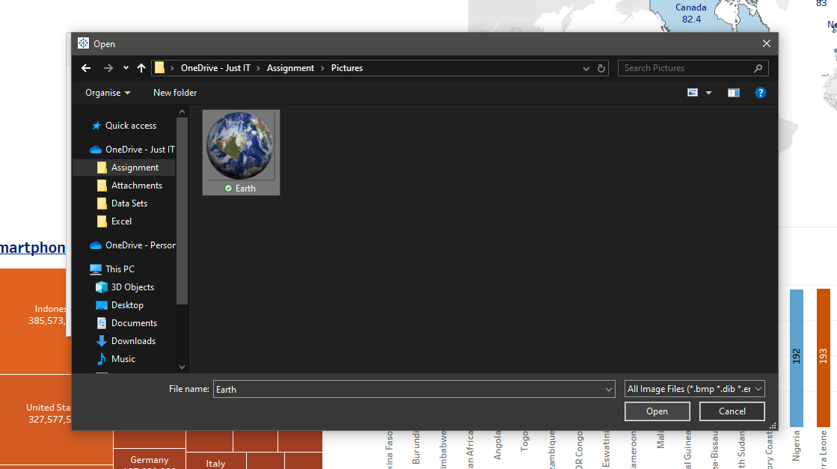

The file explorer opens allowing you to search for where you have the image you need. Once you have selected the image you want press open.

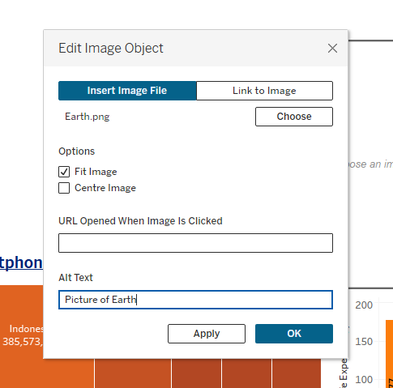

You will come back to the edit box, and I want to add an alt text to my image just in case there was an issue where the image doesn’t load, this also help users who have screen reader on to describe to the reader. Once that is added select OK.

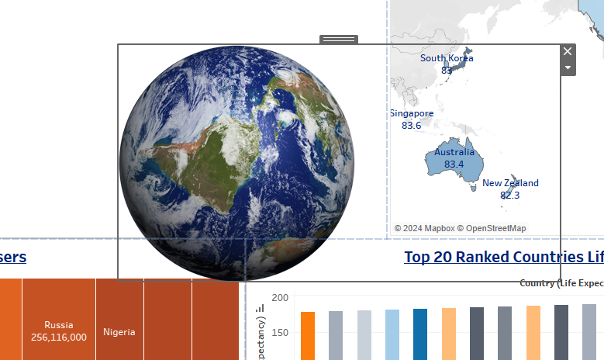

You can see here my image has loaded properly and is ready to be positioned where I want it.

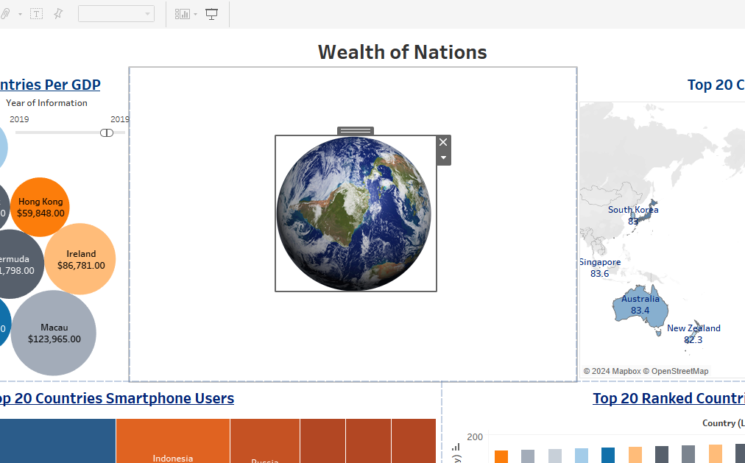

Firstly, I have adjusted the size and made the image smaller and moved it to the middle of the box. I have decided that I want to write a little description of what our dashboard is showing.

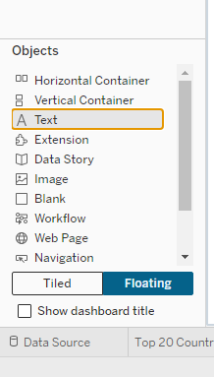

I have to add a text box to write my description, so head back to the bottom left and select text box. And drag that over to where the earth is.

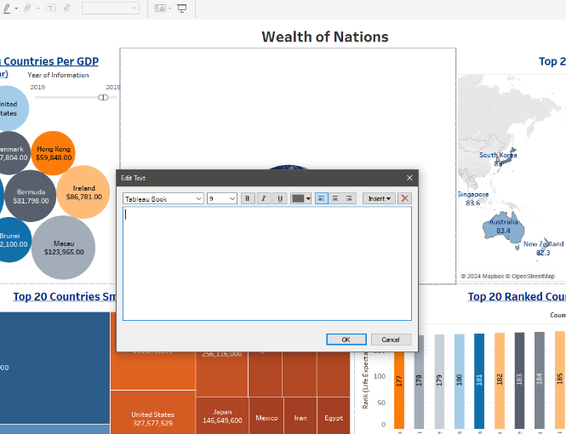

The format box will appear once the text box is placed. I am going to type out my description in this box and then format it to the way I want fitting in with our charts.

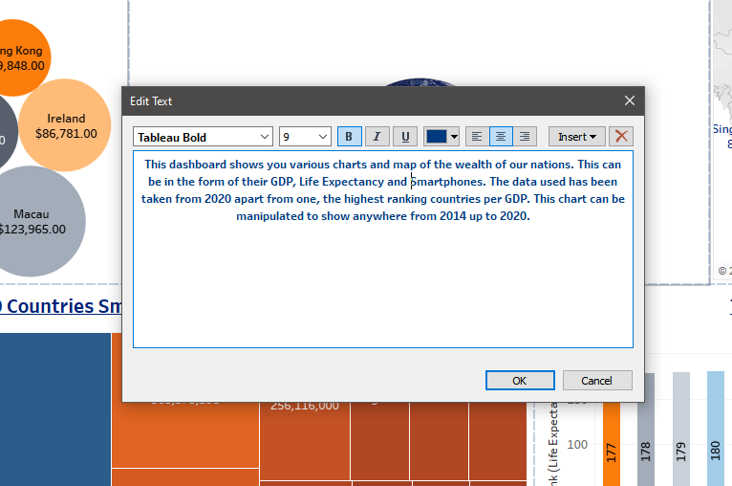

This is a preview of how my text looks, I have made my text blue to match the rest of my charts and dashboard. It is aligned to the centre so that it can fit with the picture of earth well. Press OK.

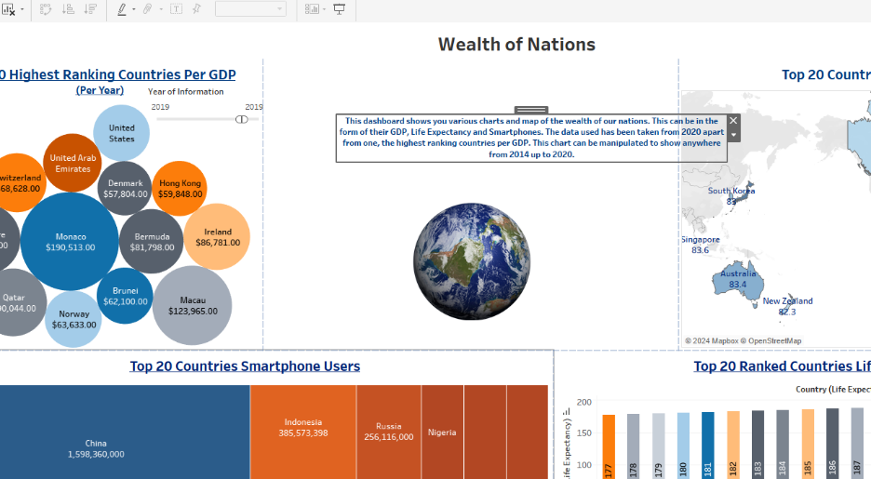

This is the text box once confirmed. As you can see that it doesn’t look very appealing, and it crosses over into the map and it will make it hard to read. We need to adjust the size and the position of it to be more central and aligned with the earth.

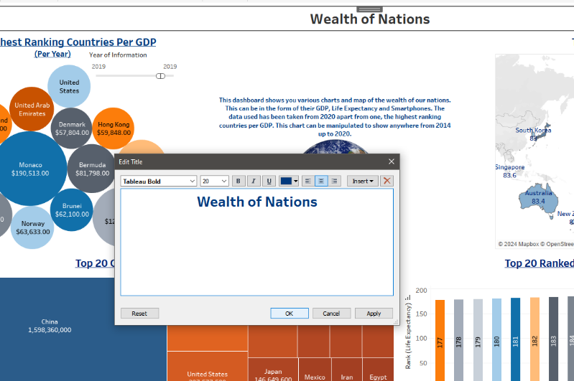

I have noticed that my title doesn’t match the rest of my dashboard, so I am going to double click the title and format the colour to the same blue that I have used over the charts.

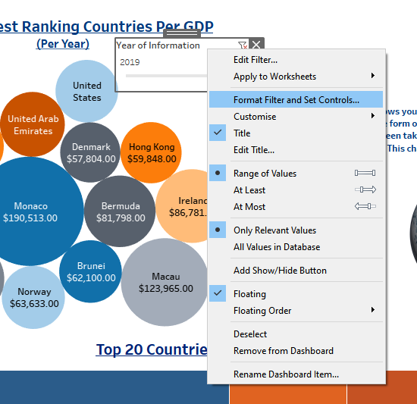 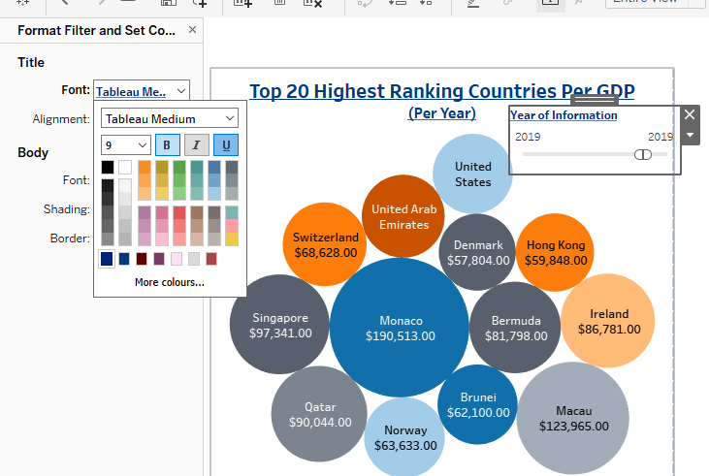

Now I am going to format the filter that we have for the top 20 highest ranking countries to match with the rest of our dashboard. I am going to right click the filter and select format filter and set controls. This will bring up a pane on the left of the page where we can change the colour, font, and alignment of the filter. I am making the text colour blue to match the rest of the dashboard.

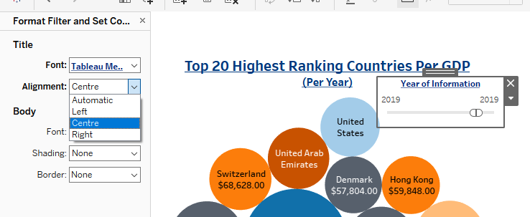 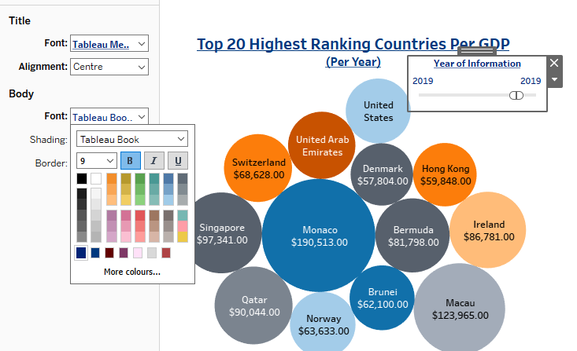

Under alignment of the filter, I am centring the title. I also come down to body and make sure that is the same blue also, this will change the years to the same colour to match.

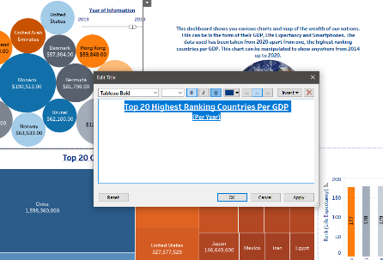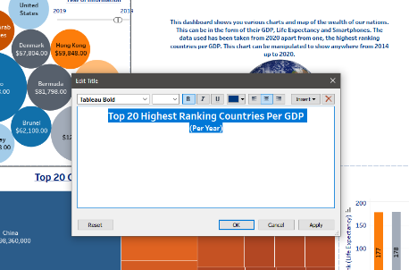

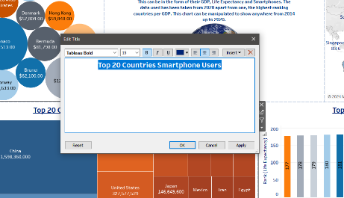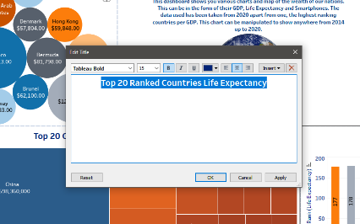

I am now going over each chart and making sure that their titles all match as I noticed some had underlines, so I am deciding to remove that and leave that for our main title of the dashboard. We just double click each title and remove the underline.

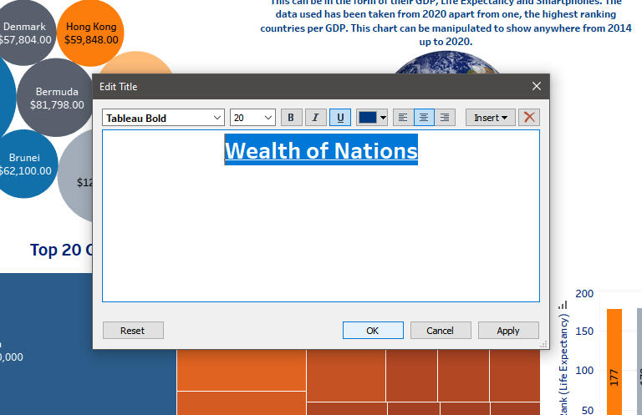

I am also doing the same to the main title. Double click and put an underline on.

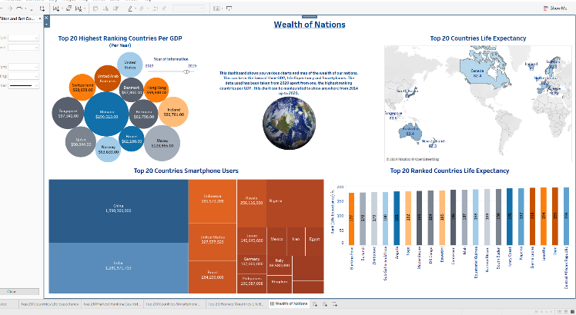

This is it. We have created a dashboard with each of our charts on and an extra feature to explain to readers what our dashboard is all about.

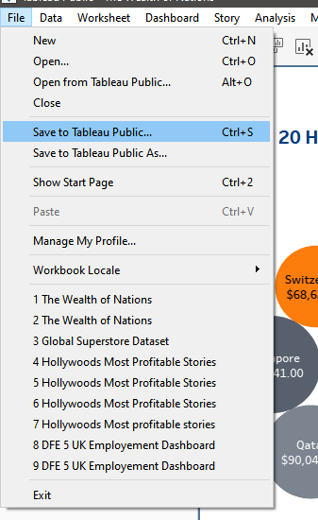

To save it is the same process as before. Go to file and select save to Tableau Public.

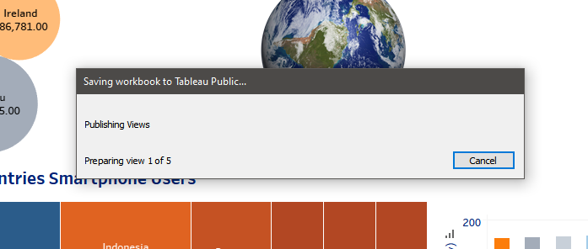

This is the progress of our dashboard saving to Tableau Public, it can take some time because we are saving all our charts and the dashboard at the same time.

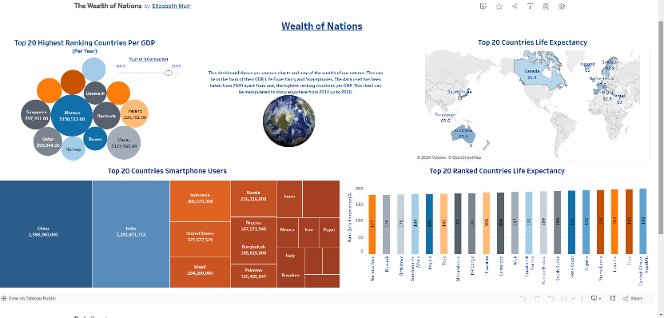

This the confirmation that our dashboard has saved and uploaded to Tableau Public. I can see some of the formatting is off with our earth and text so I will go back to change this in Tableau.

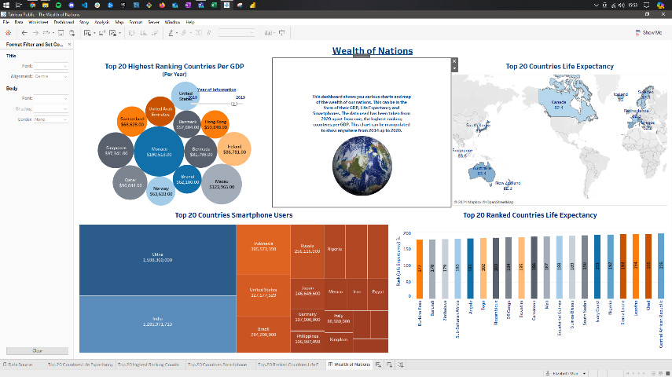

I have reduced the size of the box and text to be more centre. I also have to move the filter over a bit as the positioning moved a bit. Once everything is placed where we want it to be, I got back to file and save to Tableau Public.

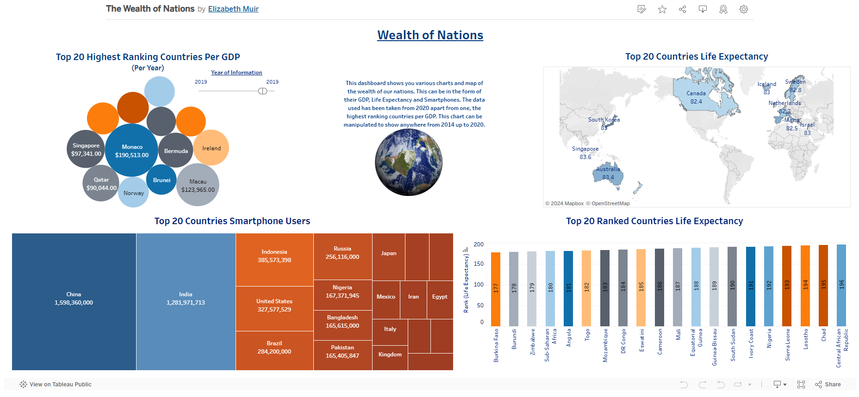

Once the progress bar has loaded the confirmation screen will appear. The dashboard looks better. The earth looks a bit off, but it sits better than what it did before.

This is the steps that were taken to create our tables in Tableau leading to a dashboard displaying each chart.

## Link to dashboard

<https://public.tableau.com/views/TheWealthofNations_17113745329420/WealthofNations?:language=en-US&:sid=&:display_count=n&:origin=viz_share_link>

# Reflections

In reflection this project was very enjoyable to complete. I have enjoyed learning how to create tables and charts in Excel with the use of filters and equations. I thoroughly enjoyed Tableau also especially it was the first time that I have used it and I have got to grips of the processes quite quickly and getting creative with the charts.

What went well for me was how easy it was to create tables and charts both for Excel and Tableau. Also, how quickly I could understand the various functions and what they are used for.

I need to further develop my skills in Tableau with practice, even though I found it easy to get used to. I did miss out changing a data type for ‘Year’ for each of the tables which may have made it easier for me to create more tables with different information shown in them. Overall, I would like to keep practicing and getting stronger to make much more complex visuals.

The lessons I have learned with this project is to be mindful of data types. In this case for ‘Year’ it was displayed as ‘2020’ as an example which I thought we would want to keep as a whole number but not thinking of the implications it could have when presenting data. I understand now using the correct data type makes sure that the data is efficient, accurate and free from errors if any equations was to be performed. I will be researching more about each data type so that next time I create visuals all my data will be very accurate.

# References

*A comprehensive guide to data handling policies - What they are and how to implement them*. (2024, Match). Retrieved from Consilien: https://www.consilien.com/news/a-comprehensive-guide-to-data-handling-policies-what-they-are-and-how-to-implement-them

*Data Protection and GDPR in the workplace*. (2024, March). Retrieved from CIPD: https://www.cipd.org/uk/knowledge/factsheets/data-protection-factsheet/

*Data Protection Policy: Key Elements to Include and 3 Best Practices*. (2024, March). Retrieved from Cloudian: https://cloudian.com/guides/data-protection/data-protection-policy-9-things-to-include-and-3-best-practices/

*European Union. (2016). General Data Protection Regulation (GDPR).* (2024, March). Retrieved from eur-lex: https://eur-lex.europa.eu/eli/reg/2016/679/oj

*Information governance and data protection*. (2024, March). Retrieved from NHS England: https://www.england.nhs.uk/long-read/information-governance-and-data-protection/

*Policies and Procedures*. (2024, March). Retrieved from ICO- Information Commissioner's Office: https://ico.org.uk/for-organisations/uk-gdpr-guidance-and-resources/accountability-and-governance/accountability-framework/policies-and-procedures/

Shaffer, J. (2024, March). *5 tips on designing colour-blind friendly visualizations*. Retrieved from Tableau: https://www.tableau.com/en-gb/blog/examining-data-viz-rules-dont-use-red-green-together#:~:text=Use%20a%20colour-blind-friendly%20palette%20when%20appropriate&text=For%20example%2C%20blue%2Forange%20is,blue%20to%20someone%20with%20CVD.

*What is GDPR, the EU’s new data protection law?* (2024, March). Retrieved from GDPR.EU: https://gdpr.eu/what-is-gdpr/